**ASSIGNMENT 1**

**Application using GUI components, Font, Colours, Layout**

**Managers and Event Listeners**

**August 30, 2023**

**Question**

Generate a Health Insurance registration form to register the patient details under each group.

**Patient Details**

* ● Assign a title for the registration form(TextView- textSize, textStyle , typeface) Group1 Patient Details
* ● Patient Name. Specify some font and colour. (use TextView, EditText-standard)
* ● Patient Phone Number (Mobile or Landline use Checkbox)
* ● Address (use TextView, EditText-standard)
* ● Age (TextView, EditText)
* ● Date of Birth (DatePicker)
* ● Gender (RadioButton)

● Marital Status (Spinner)

**Employer Details**

a) Patient Employer  
b) Employment Status (full time, parttime, unemployed, retired, student, other Checkbox)

**Emergency contact Details**

* a) Name (EditText)  
  b) Relationship (EditText)  
  c) Address (Textarea)  
  d) Phone Number (EditText- inputType, phoneNumber)  
  Use Submit (Button) to submit the details and display the contents. Use Reset button to clear the form.
* **Additional:** Display using Table layout

**Algorithm**

1. Initialize Android Form Application:
   1. Create a new Android Basic Activity project in Android Studio.
   2. Set up the necessary project structure and resources.
2. Design the User Interface (activity_main.xml):
   1. Create a ConstraintLayout as the root layout.
   2. Inside the ConstraintLayout, add a ScrollView.
   3. Inside the ScrollView, add a LinearLayout with vertical orientation.
   4. Inside the LinearLayout, add a TableLayout.
   5. Define various TableRow elements within the TableLayout.
   6. Add appropriate TextViews, EditTexts, Spinners, RadioButtons, CheckBoxes, and Buttons inside the TableRows.
   7. Configure layout constraints and attributes.
3. Populate Spinner with Marital Status Options:
   1. Get a reference to the marital status Spinner (marital_ip) from the XML layout.
   2. Create an ArrayAdapter<String> to hold the marital status options.
   3. Get the array of marital status options from the app's resources.
   4. Set the layout for the drop-down view (simple_spinner_dropdown_item).
   5. Attach the ArrayAdapter to the Spinner.
4. Implement Reset Button (reset_button):
   1. Get references to all form elements that need to be reset.
   2. Set the selected index of the marital status Spinner to 0.
   3. Clear the text of EditText fields.
   4. Uncheck all CheckBoxes and RadioButtons.
   5. Set the output TextView's text to an empty string.
5. Implement Submit Button (submit_button):
   1. Get references to all relevant EditText fields.
   2. Retrieve text, selections, and states from form elements.
   3. Construct an output string with gathered information.
   4. Set the output TextView's text to the generated output string.
6. Set Click Listeners for Buttons:
   1. Get references to the reset and submit buttons.
   2. Attach click listeners to the buttons.
   3. Inside the click listeners, implement the reset and submit actions.
7. MainActivity:
   1. Create a new class, MainActivity, that extends AppCompatActivity.
   2. Override the onCreate method.
   3. Inside onCreate, set the content view to the activity_main.xml layout.
   4. Call Step 3 to populate the Spinner.
   5. Set click listeners for buttons using Step 6.
8. Build and run the application on an Android emulator or device.

**Features Used**

**ScrollView:** The application utilizes a ScrollView to provide a scrollable view for the form.  
**TableLayout:** The form layout is structured using a TableLayout, with each input field represented by a TableRow.

**Spinner for Marital Status:** To provide a dropdown list of marital status options. **EditText for User Input:** To gather user input for various details such as name, age, address, and contact information.  
**RadioButtons and CheckBoxes:** To gather options for gender, employment status, and other choices.

**Buttons with Click Listeners:** To reset the form and submit the user's input. **TextView for Output Display:** To display the output, which is updated with the entered information when the user clicks the submit button.

**Source Code**

**//activity_main.xml**  
<?xml version="1.0" encoding="utf-8"?> <androidx.constraintlayout.widget.ConstraintLayout xmlns:android="http://schemas.android.com/apk/res/android"

xmlns:app="http://schemas.android.com/apk/res-auto"

xmlns:tools="http://schemas.android.com/tools"

android:layout_width="match_parent"

android:layout_height="match_parent"

tools:context=".MainActivity">

<ScrollView

android:layout_width="416dp"

android:layout_height="732dp"

app:layout_constraintBottom_toBottomOf="parent"

app:layout_constraintEnd_toEndOf="parent"

app:layout_constraintStart_toStartOf="parent"

app:layout_constraintTop_toTopOf="parent"

>

<LinearLayout

android:layout_width="match_parent"

android:layout_height="wrap_content"

android:orientation="vertical"

android:padding="30dp">

<TableLayout

android:layout_width="match_parent"

android:layout_height="match_parent"

android:gravity="center_horizontal"

android:stretchColumns="*" >

<TableRow

android:layout_width="match_parent"

android:layout_height="match_parent"

android:gravity="center_horizontal">

<TextView

android:id="@+id/heading"

android:layout_width="wrap_content"

android:layout_height="wrap_content"

android:fontFamily="serif"

android:text="Patient Registration System"

android:textSize="20sp" />

</TableRow>

<TableRow

android:layout_width="match_parent"

android:layout_height="match_parent"

>

<TextView

android:id="@+id/patient_details"

android:layout_width="wrap_content"

android:layout_height="wrap_content"

android:fontFamily="serif"

android:layout_marginTop="10dp"

android:text="Patient Details"

android:textSize="17sp" />

</TableRow>

<TableRow

android:layout_width="match_parent"

android:layout_height="match_parent"

android:gravity="center_horizontal">

<TextView

android:gravity="center_horizontal"

android:id="@+id/output_view"

android:layout_width="0dp"

android:layout_height="wrap_content"

android:fontFamily="serif"

android:layout_marginTop="5dp"

android:textSize="13sp"/>

</TableRow>

<TableRow

android:layout_width="match_parent"

android:layout_height="match_parent"

android:gravity="center_horizontal"

>

<TextView

android:id="@+id/name_pat"

android:layout_width="0dp"

android:layout_height="wrap_content"

android:layout_weight="2"

android:fontFamily="serif"

android:text="Name:"

android:textSize="13sp" />

<EditText

android:id="@+id/name_ip"

android:layout_width="match_parent"

android:layout_height="wrap_content"

android:ems="4"

android:layout_weight="3"

android:inputType="textPersonName" />

</TableRow>

<TableRow

android:layout_width="match_parent"

android:layout_height="match_parent"

android:gravity="center_horizontal">

<TextView

android:id="@+id/patient_ph_no"

android:layout_width="0dp"

android:layout_height="wrap_content"

android:layout_weight="2"

android:fontFamily="serif"

android:text="Phone No.:"

android:textSize="13sp" />

<CheckBox

android:id="@+id/checkBox"

android:layout_width="wrap_content"

android:layout_height="wrap_content"

android:text="Landline"

android:layout_weight="1"

android:fontFamily="serif"

android:textSize="11sp"/>

<EditText

android:id="@+id/landline_ip"

android:layout_width="wrap_content"

android:layout_height="wrap_content"

android:layout_weight="1"

android:ems="5"

android:inputType="textPersonName"

android:fontFamily="serif"/>

</TableRow>

<TableRow

android:layout_width="match_parent"

android:layout_height="match_parent" >

<TextView

android:id="@+id/patient_ph_no2"

android:layout_width="0dp"

android:layout_height="wrap_content"

android:layout_weight="2"

android:fontFamily="serif"

android:textSize="13sp" />

<CheckBox

android:id="@+id/checkBox2"

android:layout_width="wrap_content"

android:layout_height="wrap_content"

android:layout_weight="1"

android:fontFamily="serif"

android:text="Mobile"

android:textSize="11sp" />

<EditText

android:id="@+id/mobile_ip"

android:layout_width="wrap_content"

android:layout_height="wrap_content"

android:layout_weight="1"

android:ems="5"

android:fontFamily="serif"

android:inputType="textPersonName" />

</TableRow>

<TableRow

android:layout_width="match_parent"

android:layout_height="match_parent"

android:gravity="center_horizontal">

<TextView

android:id="@+id/address_pat"

android:layout_width="0dp"

android:layout_height="wrap_content"

android:layout_weight="2"

android:fontFamily="serif"

android:text="Address:"

android:textSize="13sp" />

<EditText

android:id="@+id/address_ip"

android:layout_width="match_parent"

android:layout_height="wrap_content"

android:layout_weight="3"

android:ems="4"

android:inputType="textPersonName" />

</TableRow>

<TableRow

android:layout_width="match_parent"

android:layout_height="match_parent"

android:gravity="center_horizontal">

<TextView

android:id="@+id/age_pat"

android:layout_width="0dp"

android:layout_height="wrap_content"

android:layout_weight="2"

android:fontFamily="serif"

android:text="Age:"

android:textSize="13sp" />

<EditText

android:id="@+id/age_ip"

android:layout_width="match_parent"

android:layout_height="wrap_content"

android:layout_weight="3"

android:ems="4"

android:inputType="textPersonName" />

</TableRow>

<TableRow

android:layout_width="match_parent"

android:layout_height="match_parent"

android:gravity="center_horizontal" >

<TextView

android:id="@+id/dob_pat"

android:layout_width="0dp"

android:layout_height="wrap_content"

android:layout_weight="2"

android:fontFamily="serif"

android:text="DOB:"

android:textSize="13sp" />

<EditText

android:id="@+id/dob_ip"

android:layout_width="wrap_content"

android:layout_height="wrap_content"

**Department of Computer Science and Engineering**

**UCS1711 - Mobile Computing Lab**

Gayathri G L

205001038

android:ems="10"

android:layout_weight="3"

android:inputType="date"

android:fontFamily="serif"

android:textSize="13sp"/>

</TableRow>

<TableRow

android:layout_width="match_parent"

android:layout_height="match_parent"

android:gravity="center_horizontal" >

<TextView

android:id="@+id/gender_pat"

android:layout_width="0dp"

android:layout_height="wrap_content"

android:layout_weight="1"

android:fontFamily="serif"

android:text="Gender:"

android:textSize="13sp" />

<RadioButton

android:id="@+id/male_ip"

android:layout_height="wrap_content"

android:text="Male"

android:layout_width="0dp"

android:layout_weight="1"

android:fontFamily="serif"

android:textSize="11sp"/>

<RadioButton

android:id="@+id/female_ip"

android:layout_height="wrap_content"

android:text="Female"

android:layout_width="0dp"

android:layout_weight="1"

android:fontFamily="serif"

android:textSize="11sp"/>

<RadioButton

android:id="@+id/others_ip"

android:layout_height="wrap_content"

android:text="Others"

android:layout_width="0dp"

android:layout_weight="1"

android:fontFamily="serif"

android:textSize="11sp"/>

</TableRow>

<TableRow

android:layout_width="match_parent"

android:layout_height="match_parent"

android:gravity="center_horizontal" >

<TextView

android:id="@+id/marital_pat"

android:layout_width="0dp"

android:layout_height="wrap_content"

android:layout_weight="2"

android:fontFamily="serif"

android:text="Marital Status:"

android:textSize="13sp" />

<Spinner

android:id="@+id/marital_ip"

android:layout_height="wrap_content"

android:layout_width="0dp"

android:layout_weight="4"

android:fontFamily="serif"

android:textSize="13sp" />

</TableRow>

<TableRow

android:layout_width="match_parent"

android:layout_height="match_parent"

>

<TextView

android:id="@+id/emp_details"

android:layout_width="wrap_content"

android:layout_height="wrap_content"

android:fontFamily="serif"

android:text="Employer Details"

android:layout_marginTop="15dp"

android:textSize="17sp" />

</TableRow>

<TableRow

android:layout_width="match_parent"

android:layout_height="match_parent"

android:gravity="center_horizontal" >

<TextView

android:id="@+id/name_emp"

android:layout_width="0dp"

android:layout_height="wrap_content"

android:layout_weight="2"

android:fontFamily="serif"

android:text="Name:"

android:textSize="13sp" />

<EditText

android:id="@+id/name_emp_ip"

android:layout_width="match_parent"

android:layout_height="wrap_content"

android:layout_weight="3"

android:ems="4"

android:inputType="textPersonName" />

</TableRow>

<TableRow

android:layout_width="match_parent"

android:layout_height="match_parent"

android:gravity="center_horizontal" >

<TextView

android:id="@+id/emp_status"

android:layout_width="0dp"

android:layout_height="wrap_content"

android:layout_weight="1"

android:fontFamily="serif"

android:text="Status:"

android:textSize="13sp" />

<CheckBox

android:id="@+id/full_time"

android:layout_width="0dp"

android:layout_height="wrap_content"

android:layout_weight="1"

android:fontFamily="serif"

android:text="Full Time"

android:textSize="11sp" />

<CheckBox

android:id="@+id/part_time"

android:layout_width="0dp"

android:layout_height="wrap_content"

android:layout_weight="1"

android:fontFamily="serif"

android:text="Part Time"

android:textSize="11sp" />

</TableRow>

<TableRow

android:layout_width="match_parent"

android:layout_height="match_parent"

android:gravity="center_horizontal">

<TextView

android:id="@+id/emp_status2"

android:layout_width="0dp"

android:layout_height="wrap_content"

android:layout_weight="1"

android:fontFamily="serif"

android:textSize="13sp" />

<CheckBox

android:id="@+id/retired_ip"

android:layout_width="0dp"

android:layout_height="wrap_content"

android:layout_weight="1"

android:fontFamily="serif"

android:text="Retired"

android:textSize="11sp" />

<CheckBox

android:id="@+id/unemployed_ip"

android:layout_width="0dp"

android:layout_height="wrap_content"

android:layout_weight="1"

android:fontFamily="serif"

android:text="Unemployed"

android:textSize="11sp" />

</TableRow>

<TableRow

android:layout_width="match_parent"

android:layout_height="match_parent"

android:gravity="center_horizontal" >

<TextView

android:id="@+id/emp_status3"

android:layout_width="0dp"

android:layout_height="wrap_content"

android:layout_weight="1"

android:fontFamily="serif"

android:textSize="13sp" />

<CheckBox

android:id="@+id/student_ip"

android:layout_width="0dp"

android:layout_height="wrap_content"

android:layout_weight="1"

android:fontFamily="serif"

android:text="Student"

android:textSize="11sp" />

<CheckBox

android:id="@+id/emp_others_ip"

android:layout_width="0dp"

android:layout_height="wrap_content"

android:layout_weight="1"

android:fontFamily="serif"

android:text="Others"

android:textSize="11sp" />

</TableRow>

<TableRow

android:layout_width="match_parent"

android:layout_height="match_parent"

>

<TextView

android:id="@+id/ec_details"

android:layout_width="wrap_content"

android:layout_height="wrap_content"

android:fontFamily="serif"

android:text="Emergency Contacts"

android:layout_marginTop="15dp"

android:textSize="17sp" />

</TableRow>

<TableRow

android:layout_width="match_parent"

android:layout_height="match_parent"

android:gravity="center_horizontal" >

<TextView

android:id="@+id/ec_name"

android:layout_width="0dp"

android:layout_height="wrap_content"

android:layout_weight="2"

android:fontFamily="serif"

android:text="Name:"

android:textSize="13sp" />

<EditText

android:id="@+id/name_ec_ip"

android:layout_width="match_parent"

android:layout_height="wrap_content"

android:layout_weight="3"

android:ems="4"

android:inputType="textPersonName" />

</TableRow>

<TableRow

android:layout_width="match_parent"

android:layout_height="match_parent"

android:gravity="center_horizontal" >

<TextView

android:id="@+id/relationship"

android:layout_width="0dp"

android:layout_height="wrap_content"

android:layout_weight="3"

android:fontFamily="serif"

android:text="Relationship:"

android:textSize="13sp" />

<EditText

android:id="@+id/relationship_ip"

android:layout_width="match_parent"

android:layout_height="wrap_content"

android:layout_weight="4"

android:ems="4"

android:inputType="textPersonName" />

</TableRow>

<TableRow

android:layout_width="match_parent"

android:layout_height="match_parent"

android:gravity="center_horizontal" >

<TextView

android:id="@+id/address_ec"

android:layout_width="0dp"

android:layout_height="wrap_content"

android:layout_weight="2"

android:fontFamily="serif"

android:text="Address:"

android:textSize="13sp" />

<EditText

android:id="@+id/address_ip_ec"

android:layout_width="match_parent"

android:layout_height="wrap_content"

android:layout_weight="3"

android:ems="4"

android:inputType="textPersonName" />

</TableRow>

<TableRow

android:layout_width="match_parent"

android:layout_height="match_parent"

android:gravity="center_horizontal" >

<TextView

android:id="@+id/ec_ph"

android:layout_width="0dp"

android:layout_height="wrap_content"

android:layout_weight="2"

android:fontFamily="serif"

android:text="Phone No.:"

android:textSize="13sp" />

<EditText

android:id="@+id/phno_ec_ip"

android:layout_width="wrap_content"

android:layout_height="wrap_content"

android:inputType="phone"

android:layout_weight="3"

android:ems="4"/>

</TableRow>

<TableRow

android:layout_width="match_parent"

android:layout_height="match_parent"

android:gravity="center_horizontal" >

<Button

android:id="@+id/reset_button"

android:layout_width="0dp"

android:layout_height="wrap_content"

android:layout_weight="2"

android:text="Reset"

app:backgroundTint="#6C00F8"

android:layout_marginRight="100dp"/>

<Button

android:id="@+id/submit_button"

android:layout_width="0dp"

android:layout_height="wrap_content"

android:text="Submit"

android:layout_weight="2"/>

</TableRow>

</TableLayout>

</LinearLayout>

</ScrollView>

</androidx.constraintlayout.widget.ConstraintLayout>

**//MainActivity.java**

package com.example.app1;

import androidx.appcompat.app.AppCompatActivity;

import android.os.Bundle;

import android.view.View;

import android.widget.ArrayAdapter;

import android.widget.Button;

import android.widget.CheckBox;

import android.widget.EditText;

import android.widget.RadioButton;

import android.widget.Spinner;

import android.widget.TextView;

public class MainActivity extends AppCompatActivity {

@Override

protected void onCreate(Bundle savedInstanceState) {

super.onCreate(savedInstanceState); setContentView(R.layout.*activity_main*);  
Spinner maritalSpinner = findViewById(R.id.*marital_ip*); // Get the string array from resources  
String[] maritalStatuses =

getResources().getStringArray(R.array.*marital_array*);  
// Create an ArrayAdapter using the string array and a default spinner layout ArrayAdapter<String> adapter = new ArrayAdapter<>(this,

android.R.layout.*simple_spinner_item*, maritalStatuses);  
// Specify the layout to use when the list of choices appears adapter.setDropDownViewResource(android.R.layout.*simple_spinner_dropdown_item*); // Apply the adapter to the spinner  
maritalSpinner.setAdapter(adapter);  
Button reset = findViewById(R.id.*reset_button*);  
reset.setOnClickListener(new View.OnClickListener() {

@Override

public void onClick(View v) {

maritalSpinner.setSelection(0);  
EditText name_ip = findViewById(R.id.*name_ip*); name_ip.setText("");  
EditText landline_ip = findViewById(R.id.*landline_ip*); landline_ip.setText("");  
EditText mobile_ip = findViewById(R.id.*mobile_ip*); mobile_ip.setText("");  
EditText address_ip = findViewById(R.id.*address_ip*); address_ip.setText("");  
EditText age_ip = findViewById(R.id.*age_ip*); age_ip.setText("");  
EditText dob_ip = findViewById(R.id.*dob_ip*); dob_ip.setText("");  
EditText name_emp_ip = findViewById(R.id.*name_emp_ip*); name_emp_ip.setText("");  
EditText name_ec_ip = findViewById(R.id.*name_ec_ip*); name_ec_ip.setText("");  
EditText relationship_ip = findViewById(R.id.*relationship_ip*); relationship_ip.setText("");  
EditText address_ip_ec = findViewById(R.id.*address_ip_ec*);

address_ip_ec.setText("");  
EditText phno_ec_ip = findViewById(R.id.*phno_ec_ip*); phno_ec_ip.setText("");  
RadioButton male_ip = findViewById(R.id.*male_ip*); male_ip.setChecked(false);  
RadioButton female_ip = findViewById(R.id.*female_ip*); female_ip.setChecked(false);  
RadioButton others_ip = findViewById(R.id.*others_ip*); others_ip.setChecked(false);  
CheckBox checkBox = findViewById(R.id.*checkBox*); checkBox.setChecked(false);  
CheckBox checkBox2 = findViewById(R.id.*checkBox2*); checkBox2.setChecked(false);  
CheckBox full_time = findViewById(R.id.*full_time*); full_time.setChecked(false);  
CheckBox part_time = findViewById(R.id.*part_time*); part_time.setChecked(false);  
CheckBox retired = findViewById(R.id.*retired_ip*); retired.setChecked(false);  
CheckBox emp_others_ip = findViewById(R.id.*emp_others_ip*); emp_others_ip.setChecked(false);  
CheckBox unemployed_ip = findViewById(R.id.*unemployed_ip*); unemployed_ip.setChecked(false);  
CheckBox student = findViewById(R.id.*student_ip*); student.setChecked(false);  
TextView output_view = findViewById(R.id.*output_view*); output_view.setText("");

Button submit = findViewById(R.id.*submit_button*); submit.setOnClickListener(new View.OnClickListener() {

@Override

public void onClick(View v) {

EditText name_ip = findViewById(R.id.*name_ip*);  
EditText address_ip = findViewById(R.id.*address_ip*);  
EditText age_ip = findViewById(R.id.*age_ip*);  
EditText name_emp_ip = findViewById(R.id.*name_emp_ip*); EditText name_ec_ip = findViewById(R.id.*name_ec_ip*);  
EditText relationship_ip = findViewById(R.id.*relationship_ip*); EditText phno_ec_ip = findViewById(R.id.*phno_ec_ip*);  
String output = "Output\n\n"+"Patient\nName: " +

name_ip.getText().toString() + "\n";

output += "Address: "+ address_ip.getText().toString() + "\n"

+ "Age: " + age_ip.getText().toString() + "\n"

+ "Employer\nName: " + name_emp_ip.getText().toString() + "\n"

+ "Emergency Contact\nName: " + name_ec_ip.getText().toString()

+ "\n”

+ "Relationship: " + relationship_ip.getText().toString() +

"\n"

+ "Phone Number: " + phno_ec_ip.getText().toString() + "\n";

TextView output_view = findViewById(R.id.*output_view*);

output_view.setText(output);

}

}); }

}

**//strings.xml**

<resources>

<string name="app_name">app1</string>

<string-array name="marital_array">

<item>Single</item>

<item>Married</item>

</string-array>

</resources>

**Output Screenshots**

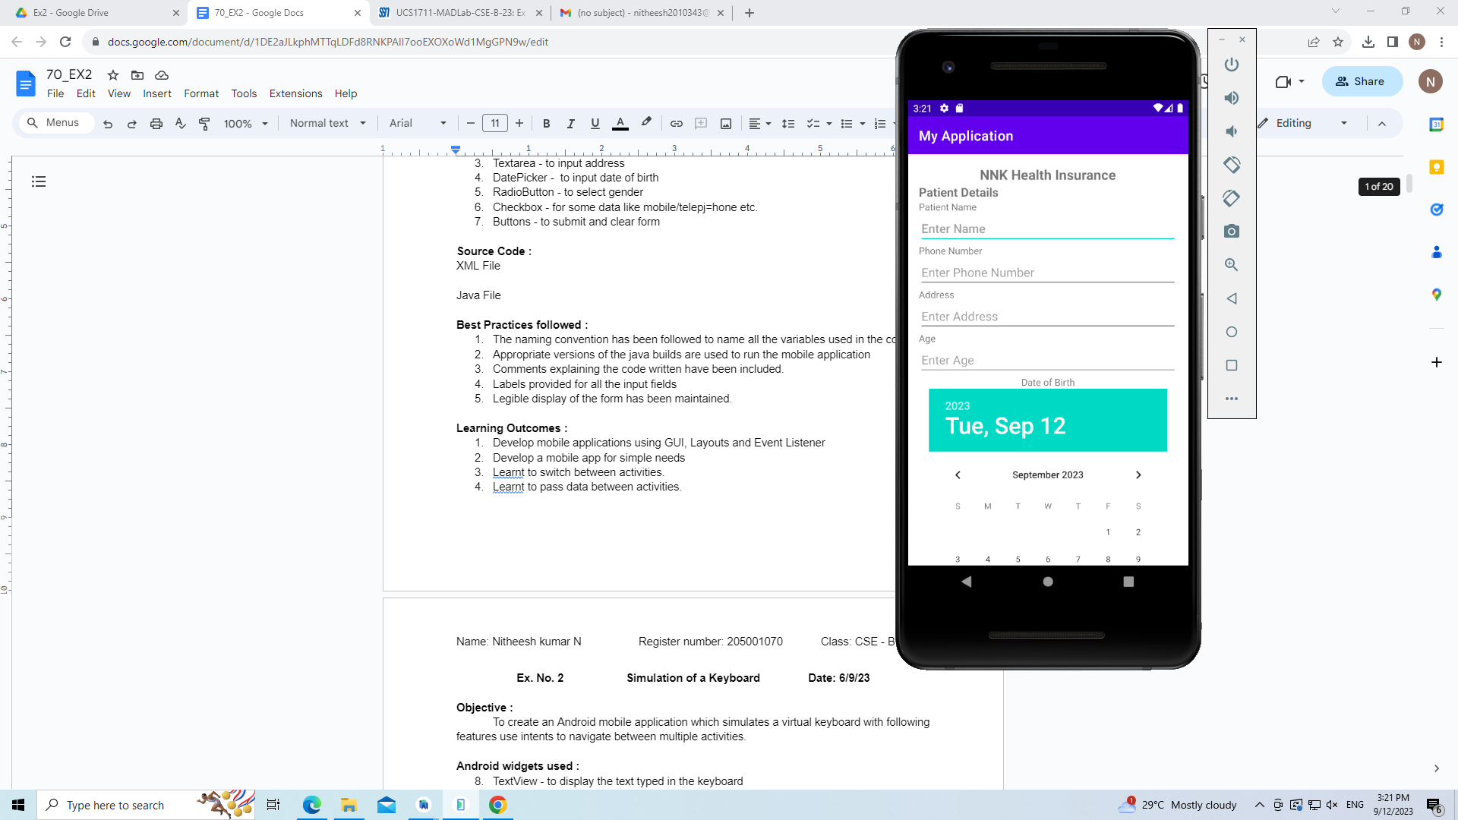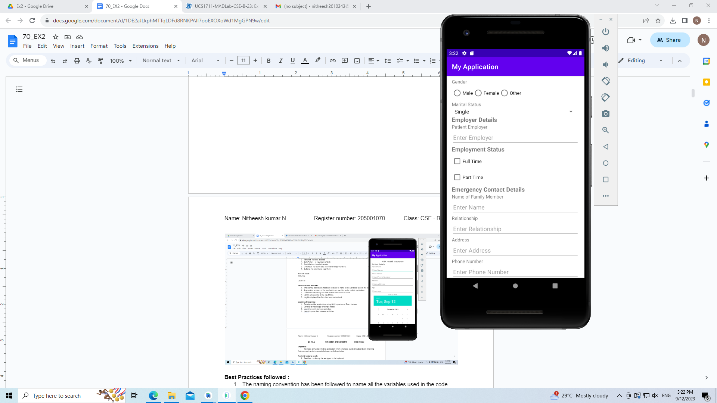

**Reset Button**

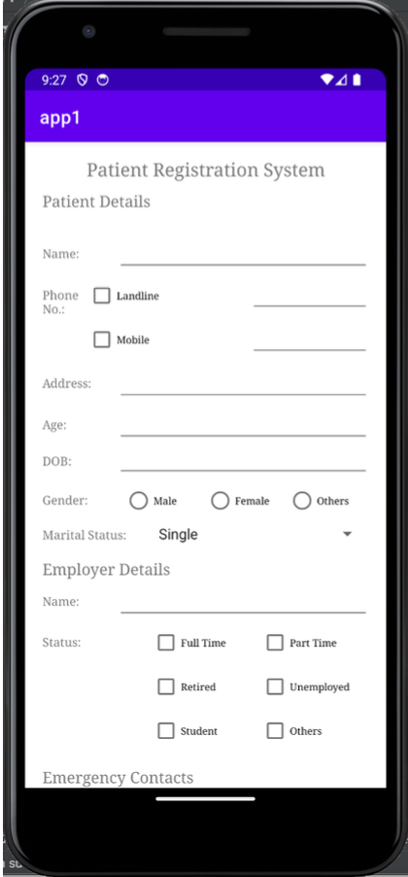

**Result**

The result of the exercise is an Android form application which acts as a consolidated

display of the user's inputted information, offering a comprehensive overview of the

submitted data.

**Best Practices**

1. Developed a responsive, scrollable application that can be viewed on devices with varying screen sizes.

2. Used standard naming conventions to make the application easier to comprehend.

**Learning outcomes:**

* ● An android app was designed and implemented.
* ● A registration form was designed for a mobile application.
* **ASSIGNMENT 2**
* **Simulation of a Keyboard**
* **September 06, 2023**

**Question**

Create an Android mobile application which simulates a virtual keyboard with following features that use intents to navigate between multiple activities.

* Use Grid Layout with each cell containing individual characters / numbers / special characters
* A TextView (multiple lines) to display the typed content.

**Algorithm**

1. Initialize MainActivity:

Initialize EditText field (text)

1. OnCreate:

Set content view to activity_main layout

Initialize letter and number buttons (e.g., n8, n9)

Set up click listeners for letter and number buttons:

When n8 is clicked:

Append "8" to the EditText field's current text

When n9 is clicked:

Append "9" to the EditText field's current text

1. Initialize Backspace Button:

OnClick:

Retrieve the current text from the EditText field (s)

Remove the last character from s

Update the EditText field with the modified text (s)

1. Initialize Space Button:

OnClick:

Append a space character to the EditText field's current text

**Source Code**

**//activity_main.xml**  
<?xml version="1.0" encoding="utf-8"?>

<androidx.constraintlayout.widget.ConstraintLayout xmlns:android="http://schemas.android.com/apk/res/android"

xmlns:app="http://schemas.android.com/apk/res-auto"

xmlns:tools="http://schemas.android.com/tools"

android:layout_width="match_parent"

android:layout_height="match_parent"

tools:context=".MainActivity">

<Button

android:id="@+id/n4"

android:layout_width="40dp"

android:layout_height="37dp"

android:text="4"

android:textSize="13dp"

app:backgroundTint="#7741D8"

app:layout_constraintBottom_toBottomOf="parent"

app:layout_constraintEnd_toEndOf="parent"

app:layout_constraintHorizontal_bias="0.625"

app:layout_constraintStart_toStartOf="parent"

app:layout_constraintTop_toTopOf="parent"

app:layout_constraintVertical_bias="0.913" />

<Button

android:id="@+id/n9"

android:layout_width="40dp"

android:layout_height="37dp"

android:text="9"

android:textSize="13dp"

app:backgroundTint="#7741D8"

app:layout_constraintBottom_toBottomOf="parent"

app:layout_constraintEnd_toEndOf="parent"

app:layout_constraintHorizontal_bias="0.625"

app:layout_constraintStart_toStartOf="parent"

app:layout_constraintTop_toTopOf="parent"

app:layout_constraintVertical_bias="0.966" />

<Button

android:id="@+id/n0"

android:layout_width="40dp"

android:layout_height="37dp"

android:text="0"

android:textSize="13dp"

app:backgroundTint="#7741D8"

app:layout_constraintBottom_toBottomOf="parent"

app:layout_constraintEnd_toEndOf="parent"

app:layout_constraintHorizontal_bias="0.115"

app:layout_constraintStart_toStartOf="parent"

app:layout_constraintTop_toTopOf="parent"

app:layout_constraintVertical_bias="0.913" />

<Button

android:id="@+id/n1"

android:layout_width="40dp"

android:layout_height="37dp"

android:text="1"

android:textSize="13dp"

app:backgroundTint="#7741D8"

app:layout_constraintBottom_toBottomOf="parent"

app:layout_constraintEnd_toEndOf="parent"

app:layout_constraintHorizontal_bias="0.239"

app:layout_constraintStart_toStartOf="parent"

app:layout_constraintTop_toTopOf="parent"

app:layout_constraintVertical_bias="0.913" />

<Button

android:id="@+id/n7"

android:layout_width="40dp"

android:layout_height="37dp"

android:text="7"

android:textSize="13dp"

app:backgroundTint="#7741D8"

app:layout_constraintBottom_toBottomOf="parent"

app:layout_constraintEnd_toEndOf="parent"

app:layout_constraintHorizontal_bias="0.369"

app:layout_constraintStart_toStartOf="parent"

app:layout_constraintTop_toTopOf="parent"

app:layout_constraintVertical_bias="0.966" />

<Button

android:id="@+id/n6"

android:layout_width="40dp"

android:layout_height="37dp"

android:text="6"

android:textSize="13dp"

app:backgroundTint="#7741D8"

app:layout_constraintBottom_toBottomOf="parent"

app:layout_constraintEnd_toEndOf="parent"

app:layout_constraintHorizontal_bias="0.884"

app:layout_constraintStart_toStartOf="parent"

app:layout_constraintTop_toTopOf="parent"

app:layout_constraintVertical_bias="0.913" />

<Button

android:id="@+id/n8"

android:layout_width="40dp"

android:layout_height="37dp"

android:text="8"

android:textSize="13dp"

app:backgroundTint="#7741D8"

app:layout_constraintBottom_toBottomOf="parent"

app:layout_constraintEnd_toEndOf="parent"

app:layout_constraintHorizontal_bias="0.498"

app:layout_constraintStart_toStartOf="parent"

app:layout_constraintTop_toTopOf="parent"

app:layout_constraintVertical_bias="0.966" />

<Button

android:id="@+id/n2"

android:layout_width="40dp"

android:layout_height="37dp"

android:text="2"

android:textSize="13dp"

app:backgroundTint="#7741D8"

app:layout_constraintBottom_toBottomOf="parent"

app:layout_constraintEnd_toEndOf="parent"

app:layout_constraintHorizontal_bias="0.369"

app:layout_constraintStart_toStartOf="parent"

app:layout_constraintTop_toTopOf="parent"

app:layout_constraintVertical_bias="0.913" />

<Button

android:id="@+id/n5"

android:layout_width="40dp"

android:layout_height="37dp"

android:text="5"

android:textSize="13dp"

app:backgroundTint="#7741D8"

app:layout_constraintBottom_toBottomOf="parent"

app:layout_constraintEnd_toEndOf="parent"

app:layout_constraintHorizontal_bias="0.754"

app:layout_constraintStart_toStartOf="parent"

app:layout_constraintTop_toTopOf="parent"

app:layout_constraintVertical_bias="0.913" />

<Button

android:id="@+id/n3"

android:layout_width="40dp"

android:layout_height="37dp"

android:text="3"

android:textSize="13dp"

app:backgroundTint="#7741D8"

app:layout_constraintBottom_toBottomOf="parent"

app:layout_constraintEnd_toEndOf="parent"

app:layout_constraintHorizontal_bias="0.498"

app:layout_constraintStart_toStartOf="parent"

app:layout_constraintTop_toTopOf="parent"

app:layout_constraintVertical_bias="0.913" />

<Button

android:id="@+id/hide"

android:layout_width="wrap_content"

android:layout_height="wrap_content"

android:text="clear"

app:layout_constraintBottom_toBottomOf="parent"

app:layout_constraintEnd_toEndOf="parent"

app:layout_constraintHorizontal_bias="0.176"

app:layout_constraintStart_toStartOf="parent"

app:layout_constraintTop_toTopOf="parent"

app:layout_constraintVertical_bias="0.344" />

<Button

android:id="@+id/show"

android:layout_width="wrap_content"

android:layout_height="wrap_content"

android:text="Type"

app:layout_constraintBottom_toBottomOf="parent"

app:layout_constraintEnd_toEndOf="parent"

app:layout_constraintHorizontal_bias="0.82"

app:layout_constraintStart_toStartOf="parent"

app:layout_constraintTop_toTopOf="parent"

app:layout_constraintVertical_bias="0.344" />

<EditText

android:id="@+id/edit"

android:layout_width="296dp"

android:layout_height="122dp"

android:ems="10"

android:gravity="start|top"

android:inputType="textMultiLine"

android:visibility="invisible"

app:layout_constraintBottom_toBottomOf="parent"

app:layout_constraintEnd_toEndOf="parent"

app:layout_constraintHorizontal_bias="0.495"

app:layout_constraintStart_toStartOf="parent"

app:layout_constraintTop_toTopOf="parent"

app:layout_constraintVertical_bias="0.111" />

<Button

android:id="@+id/e"

android:layout_width="45dp"

android:layout_height="55dp"

android:text="E"

app:layout_constraintBottom_toBottomOf="parent"

app:layout_constraintEnd_toEndOf="parent"

app:layout_constraintHorizontal_bias="0.743"

app:layout_constraintStart_toStartOf="parent"

app:layout_constraintTop_toTopOf="parent"

app:layout_constraintVertical_bias="0.44" />

<Button

android:id="@+id/u"

android:layout_width="45dp"

android:layout_height="55dp"

android:text="U"

app:layout_constraintBottom_toBottomOf="parent"

app:layout_constraintEnd_toEndOf="parent"

app:layout_constraintHorizontal_bias="0.418"

app:layout_constraintStart_toStartOf="parent"

app:layout_constraintTop_toTopOf="parent"

app:layout_constraintVertical_bias="0.741" />

<Button

android:id="@+id/g"

android:layout_width="45dp"

android:layout_height="55dp"

android:text="G"

app:layout_constraintBottom_toBottomOf="parent"

app:layout_constraintEnd_toEndOf="parent"

app:layout_constraintHorizontal_bias="0.09"

app:layout_constraintStart_toStartOf="parent"

app:layout_constraintTop_toTopOf="parent"

app:layout_constraintVertical_bias="0.542" />

<Button

android:id="@+id/j"

android:layout_width="45dp"

android:layout_height="55dp"

android:text="J"

app:layout_constraintBottom_toBottomOf="parent"

app:layout_constraintEnd_toEndOf="parent"

app:layout_constraintHorizontal_bias="0.579"

app:layout_constraintStart_toStartOf="parent"

app:layout_constraintTop_toTopOf="parent"

app:layout_constraintVertical_bias="0.542" />

<Button

android:id="@+id/w"

android:layout_width="45dp"

android:layout_height="55dp"

android:text="W"

app:layout_constraintBottom_toBottomOf="parent"

app:layout_constraintEnd_toEndOf="parent"

app:layout_constraintHorizontal_bias="0.743"

app:layout_constraintStart_toStartOf="parent"

app:layout_constraintTop_toTopOf="parent"

app:layout_constraintVertical_bias="0.741" />

<Button

android:id="@+id/y"

android:layout_width="45dp"

android:layout_height="55dp"

android:text="Y"

app:layout_constraintBottom_toBottomOf="parent"

app:layout_constraintEnd_toEndOf="parent"

app:layout_constraintHorizontal_bias="0.418"

app:layout_constraintStart_toStartOf="parent"

app:layout_constraintTop_toTopOf="parent"

app:layout_constraintVertical_bias="0.837" />

<Button

android:id="@+id/space"

android:layout_width="104dp"

android:layout_height="54dp"

android:text="space"

app:layout_constraintBottom_toBottomOf="parent"

app:layout_constraintEnd_toEndOf="parent"

app:layout_constraintHorizontal_bias="0.107"

app:layout_constraintStart_toStartOf="parent"

app:layout_constraintTop_toTopOf="parent"

app:layout_constraintVertical_bias="0.837" />

<Button

android:id="@+id/backspace"

android:layout_width="104dp"

android:layout_height="54dp"

android:text="Delete"

app:layout_constraintBottom_toBottomOf="parent"

app:layout_constraintEnd_toEndOf="parent"

app:layout_constraintHorizontal_bias="0.892"

app:layout_constraintStart_toStartOf="parent"

app:layout_constraintTop_toTopOf="parent"

app:layout_constraintVertical_bias="0.838" />

<Button

android:id="@+id/h"

android:layout_width="45dp"

android:layout_height="55dp"

android:text="H"

app:layout_constraintBottom_toBottomOf="parent"

app:layout_constraintEnd_toEndOf="parent"

app:layout_constraintHorizontal_bias="0.251"

app:layout_constraintStart_toStartOf="parent"

app:layout_constraintTop_toTopOf="parent"

app:layout_constraintVertical_bias="0.542" />

<Button

android:id="@+id/p"

android:layout_width="45dp"

android:layout_height="55dp"

android:text="P"

app:layout_constraintBottom_toBottomOf="parent"

app:layout_constraintEnd_toEndOf="parent"

app:layout_constraintHorizontal_bias="0.579"

app:layout_constraintStart_toStartOf="parent"

app:layout_constraintTop_toTopOf="parent"

app:layout_constraintVertical_bias="0.643" />

<Button

android:id="@+id/o"

android:layout_width="45dp"

android:layout_height="55dp"

android:text="O"

app:layout_constraintBottom_toBottomOf="parent"

app:layout_constraintEnd_toEndOf="parent"

app:layout_constraintHorizontal_bias="0.418"

app:layout_constraintStart_toStartOf="parent"

app:layout_constraintTop_toTopOf="parent"

app:layout_constraintVertical_bias="0.643" />

<Button

android:id="@+id/i"

android:layout_width="45dp"

android:layout_height="55dp"

android:text="I"

app:layout_constraintBottom_toBottomOf="parent"

app:layout_constraintEnd_toEndOf="parent"

app:layout_constraintHorizontal_bias="0.418"

app:layout_constraintStart_toStartOf="parent"

app:layout_constraintTop_toTopOf="parent"

app:layout_constraintVertical_bias="0.542" />

<Button

android:id="@+id/x"

android:layout_width="45dp"

android:layout_height="55dp"

android:text="X"

app:layout_constraintBottom_toBottomOf="parent"

app:layout_constraintEnd_toEndOf="parent"

app:layout_constraintHorizontal_bias="0.909"

app:layout_constraintStart_toStartOf="parent"

app:layout_constraintTop_toTopOf="parent"

app:layout_constraintVertical_bias="0.741" />

<Button

android:id="@+id/d"

android:layout_width="45dp"

android:layout_height="55dp"

android:text="D"

app:layout_constraintBottom_toBottomOf="parent"

app:layout_constraintEnd_toEndOf="parent"

app:layout_constraintHorizontal_bias="0.579"

app:layout_constraintStart_toStartOf="parent"

app:layout_constraintTop_toTopOf="parent"

app:layout_constraintVertical_bias="0.44" />

<Button

android:id="@+id/k"

android:layout_width="45dp"

android:layout_height="55dp"

android:text="K"

app:layout_constraintBottom_toBottomOf="parent"

app:layout_constraintEnd_toEndOf="parent"

app:layout_constraintHorizontal_bias="0.743"

app:layout_constraintStart_toStartOf="parent"

app:layout_constraintTop_toTopOf="parent"

app:layout_constraintVertical_bias="0.542" />

<Button

android:id="@+id/n"

android:layout_width="45dp"

android:layout_height="55dp"

android:text="N"

app:layout_constraintBottom_toBottomOf="parent"

app:layout_constraintEnd_toEndOf="parent"

app:layout_constraintHorizontal_bias="0.251"

app:layout_constraintStart_toStartOf="parent"

app:layout_constraintTop_toTopOf="parent"

app:layout_constraintVertical_bias="0.643" />

<Button

android:id="@+id/r"

android:layout_width="45dp"

android:layout_height="55dp"

android:text="R"

app:layout_constraintBottom_toBottomOf="parent"

app:layout_constraintEnd_toEndOf="parent"

app:layout_constraintHorizontal_bias="0.909"

app:layout_constraintStart_toStartOf="parent"

app:layout_constraintTop_toTopOf="parent"

app:layout_constraintVertical_bias="0.643" />

<Button

android:id="@+id/z"

android:layout_width="45dp"

android:layout_height="55dp"

android:text="Z"

app:layout_constraintBottom_toBottomOf="parent"

app:layout_constraintEnd_toEndOf="parent"

app:layout_constraintHorizontal_bias="0.579"

app:layout_constraintStart_toStartOf="parent"

app:layout_constraintTop_toTopOf="parent"

app:layout_constraintVertical_bias="0.838" />

<Button

android:id="@+id/m"

android:layout_width="45dp"

android:layout_height="55dp"

android:text="M"

app:layout_constraintBottom_toBottomOf="parent"

app:layout_constraintEnd_toEndOf="parent"

app:layout_constraintHorizontal_bias="0.09"

app:layout_constraintStart_toStartOf="parent"

app:layout_constraintTop_toTopOf="parent"

app:layout_constraintVertical_bias="0.643" />

<Button

android:id="@+id/l"

android:layout_width="45dp"

android:layout_height="55dp"

android:text="L"

app:layout_constraintBottom_toBottomOf="parent"

app:layout_constraintEnd_toEndOf="parent"

app:layout_constraintHorizontal_bias="0.909"

app:layout_constraintStart_toStartOf="parent"

app:layout_constraintTop_toTopOf="parent"

app:layout_constraintVertical_bias="0.542" />

<Button

android:id="@+id/t"

android:layout_width="45dp"

android:layout_height="55dp"

android:text="T"

app:layout_constraintBottom_toBottomOf="parent"

app:layout_constraintEnd_toEndOf="parent"

app:layout_constraintHorizontal_bias="0.251"

app:layout_constraintStart_toStartOf="parent"

app:layout_constraintTop_toTopOf="parent"

app:layout_constraintVertical_bias="0.741" />

<Button

android:id="@+id/a"

android:layout_width="45dp"

android:layout_height="55dp"

android:text="A"

app:layout_constraintBottom_toBottomOf="parent"

app:layout_constraintEnd_toEndOf="parent"

app:layout_constraintHorizontal_bias="0.09"

app:layout_constraintStart_toStartOf="parent"

app:layout_constraintTop_toTopOf="parent"

app:layout_constraintVertical_bias="0.44" />

<Button

android:id="@+id/q"

android:layout_width="45dp"

android:layout_height="55dp"

android:text="Q"

app:layout_constraintBottom_toBottomOf="parent"

app:layout_constraintEnd_toEndOf="parent"

app:layout_constraintHorizontal_bias="0.743"

app:layout_constraintStart_toStartOf="parent"

app:layout_constraintTop_toTopOf="parent"

app:layout_constraintVertical_bias="0.643" />

<Button

android:id="@+id/b"

android:layout_width="45dp"

android:layout_height="55dp"

android:text="B"

app:layout_constraintBottom_toBottomOf="parent"

app:layout_constraintEnd_toEndOf="parent"

app:layout_constraintHorizontal_bias="0.251"

app:layout_constraintStart_toStartOf="parent"

app:layout_constraintTop_toTopOf="parent"

app:layout_constraintVertical_bias="0.44" />

<Button

android:id="@+id/c"

android:layout_width="45dp"

android:layout_height="55dp"

android:text="C"

app:layout_constraintBottom_toBottomOf="parent"

app:layout_constraintEnd_toEndOf="parent"

app:layout_constraintHorizontal_bias="0.418"

app:layout_constraintStart_toStartOf="parent"

app:layout_constraintTop_toTopOf="parent"

app:layout_constraintVertical_bias="0.44" />

<Button

android:id="@+id/s"

android:layout_width="45dp"

android:layout_height="55dp"

android:text="S"

app:layout_constraintBottom_toBottomOf="parent"

app:layout_constraintEnd_toEndOf="parent"

app:layout_constraintHorizontal_bias="0.09"

app:layout_constraintStart_toStartOf="parent"

app:layout_constraintTop_toTopOf="parent"

app:layout_constraintVertical_bias="0.741" />

<Button

android:id="@+id/v"

android:layout_width="45dp"

android:layout_height="55dp"

android:text="V"

app:layout_constraintBottom_toBottomOf="parent"

app:layout_constraintEnd_toEndOf="parent"

app:layout_constraintHorizontal_bias="0.579"

app:layout_constraintStart_toStartOf="parent"

app:layout_constraintTop_toTopOf="parent"

app:layout_constraintVertical_bias="0.741" />

<Button

android:id="@+id/f"

android:layout_width="45dp"

android:layout_height="55dp"

android:text="F"

app:layout_constraintBottom_toBottomOf="parent"

app:layout_constraintEnd_toEndOf="parent"

app:layout_constraintHorizontal_bias="0.909"

app:layout_constraintStart_toStartOf="parent"

app:layout_constraintTop_toTopOf="parent"

app:layout_constraintVertical_bias="0.44" />

</androidx.constraintlayout.widget.ConstraintLayout>

**//MainActivity.java**

package com.example.app2;

import androidx.appcompat.app.AppCompatActivity;

import android.os.Bundle;

import android.view.View;

import android.widget.Button;

import android.widget.EditText;

public class MainActivity extends AppCompatActivity {

@Override

protected void onCreate(Bundle savedInstanceState) {

super.onCreate(savedInstanceState);

setContentView(R.layout.*activity_main*);

Button show= (Button) findViewById(R.id.*show*);

Button hide=(Button) findViewById(R.id.*hide*);

EditText text=(EditText) findViewById(R.id.*edit*);

Button a= (Button) findViewById(R.id.*a*);

Button b=(Button) findViewById(R.id.*b*);

Button c=(Button) findViewById(R.id.*c*);

Button d=(Button) findViewById(R.id.*d*);

Button e=(Button) findViewById(R.id.*e*);

Button f= (Button) findViewById(R.id.*f*);

Button g=(Button) findViewById(R.id.*g*);

Button h=(Button) findViewById(R.id.*h*);

Button i=(Button) findViewById(R.id.*i*);

Button j=(Button) findViewById(R.id.*j*);

Button k=(Button) findViewById(R.id.*k*);

Button l=(Button) findViewById(R.id.*l*);

Button m=(Button) findViewById(R.id.*m*);

Button n=(Button) findViewById(R.id.*n*);

Button o=(Button) findViewById(R.id.*o*);

Button p=(Button) findViewById(R.id.*p*);

Button q=(Button) findViewById(R.id.*q*);

Button r=(Button) findViewById(R.id.*r*);

Button s=(Button) findViewById(R.id.*s*);

Button t=(Button) findViewById(R.id.*t*);

Button u=(Button) findViewById(R.id.*u*);

Button v=(Button) findViewById(R.id.*v*);

Button w=(Button) findViewById(R.id.*w*);

Button x=(Button) findViewById(R.id.*x*);

Button y=(Button) findViewById(R.id.*y*);

Button z=(Button) findViewById(R.id.*z*);

Button n0=(Button) findViewById(R.id.*n0*);

Button n1=(Button) findViewById(R.id.*n1*);

Button n2=(Button) findViewById(R.id.*n2*);

Button n3=(Button) findViewById(R.id.*n3*);

Button n4=(Button) findViewById(R.id.*n4*);

Button n5=(Button) findViewById(R.id.*n5*);

Button n6=(Button) findViewById(R.id.*n6*);

Button n8=(Button) findViewById(R.id.*n8*);

Button n9=(Button) findViewById(R.id.*n9*);

Button n7=(Button) findViewById(R.id.*n7*);

Button space=(Button) findViewById(R.id.*space*);

Button backspace=(Button) findViewById(R.id.*backspace*);

show.setOnClickListener(new View.OnClickListener() {

@Override

public void onClick(View v) {

// Make the EditText visible

text.setVisibility(View.*VISIBLE*);

//text.setText(text.getText().toString() + "A");

}

});

// Set onClickListener for the "Hide" button

hide.setOnClickListener(new View.OnClickListener() {

@Override

public void onClick(View v) {

// Make the EditText not visible (Gone)

text.setText("");

}

});

a.setOnClickListener(new View.OnClickListener() {

@Override

public void onClick(View v) {

// Make the EditText visible

text.setText(text.getText().toString() + "A");

}

});

b.setOnClickListener(new View.OnClickListener() {

@Override

public void onClick(View v) {

// Make the EditText visible

text.setText(text.getText().toString() + "B");

}

});

c.setOnClickListener(new View.OnClickListener() {

@Override

public void onClick(View v) {

// Make the EditText visible

text.setText(text.getText().toString() + "C");

}

});

d.setOnClickListener(new View.OnClickListener() {

@Override

public void onClick(View v) {

// Make the EditText visible

text.setText(text.getText().toString() + "D");

}

});

e.setOnClickListener(new View.OnClickListener() {

@Override

public void onClick(View v) {

// Make the EditText visible

text.setText(text.getText().toString() + "E");

}

});

f.setOnClickListener(new View.OnClickListener() {

@Override

public void onClick(View v) {

// Make the EditText visible

text.setText(text.getText().toString() + "F");

}

});

g.setOnClickListener(new View.OnClickListener() {

@Override

public void onClick(View v) {

// Make the EditText visible

text.setText(text.getText().toString() + "G");

}

});

h.setOnClickListener(new View.OnClickListener() {

@Override

public void onClick(View v) {

// Make the EditText visible

text.setText(text.getText().toString() + "H");

}

});

i.setOnClickListener(new View.OnClickListener() {

@Override

public void onClick(View v) {

// Make the EditText visible

text.setText(text.getText().toString() + "I");

}

});

j.setOnClickListener(new View.OnClickListener() {

@Override

public void onClick(View v) {

// Make the EditText visible

text.setText(text.getText().toString() + "J");

}

});

k.setOnClickListener(new View.OnClickListener() {

@Override

public void onClick(View v) {

// Make the EditText visible

text.setText(text.getText().toString() + "K");

}

});

l.setOnClickListener(new View.OnClickListener() {

@Override

public void onClick(View v) {

// Make the EditText visible

text.setText(text.getText().toString() + "L");

}

});

m.setOnClickListener(new View.OnClickListener() {

@Override

public void onClick(View v) {

// Make the EditText visible

text.setText(text.getText().toString() + "M");

}

});

n.setOnClickListener(new View.OnClickListener() {

@Override

public void onClick(View v) {

// Make the EditText visible

text.setText(text.getText().toString() + "N");

}

});

o.setOnClickListener(new View.OnClickListener() {

@Override

public void onClick(View v) {

// Make the EditText visible

text.setText(text.getText().toString() + "O");

}

});

p.setOnClickListener(new View.OnClickListener() {

@Override

public void onClick(View v) {

// Make the EditText visible

text.setText(text.getText().toString() + "P");

}

});

q.setOnClickListener(new View.OnClickListener() {

@Override

public void onClick(View v) {

// Make the EditText visible

text.setText(text.getText().toString() + "Q");

}

});

r.setOnClickListener(new View.OnClickListener() {

@Override

public void onClick(View v) {

// Make the EditText visible

text.setText(text.getText().toString() + "R");

}

});

s.setOnClickListener(new View.OnClickListener() {

@Override

public void onClick(View v) {

// Make the EditText visible

text.setText(text.getText().toString() + "S");

}

});

t.setOnClickListener(new View.OnClickListener() {

@Override

public void onClick(View v) {

// Make the EditText visible

text.setText(text.getText().toString() + "T");

}

});

u.setOnClickListener(new View.OnClickListener() {

@Override

public void onClick(View v) {

// Make the EditText visible

text.setText(text.getText().toString() + "U");

}

});

v.setOnClickListener(new View.OnClickListener() {

@Override

public void onClick(View v) {

// Make the EditText visible

text.setText(text.getText().toString() + "V");

}

});

w.setOnClickListener(new View.OnClickListener() {

@Override

public void onClick(View v) {

// Make the EditText visible

text.setText(text.getText().toString() + "W");

}

});

x.setOnClickListener(new View.OnClickListener() {

@Override

public void onClick(View v) {

// Make the EditText visible

text.setText(text.getText().toString() + "X");

}

});

y.setOnClickListener(new View.OnClickListener() {

@Override

public void onClick(View v) {

// Make the EditText visible

text.setText(text.getText().toString() + "Y");

}

});

z.setOnClickListener(new View.OnClickListener() {

@Override

public void onClick(View v) {

// Make the EditText visible

text.setText(text.getText().toString() + "Z");

}

});

n0.setOnClickListener(new View.OnClickListener() {

@Override

public void onClick(View v) {

// Make the EditText visible

text.setText(text.getText().toString() + "0");

}

});

n1.setOnClickListener(new View.OnClickListener() {

@Override

public void onClick(View v) {

// Make the EditText visible

text.setText(text.getText().toString() + "1");

}

});

n2.setOnClickListener(new View.OnClickListener() {

@Override

public void onClick(View v) {

// Make the EditText visible

text.setText(text.getText().toString() + "2");

}

});

n3.setOnClickListener(new View.OnClickListener() {

@Override

public void onClick(View v) {

// Make the EditText visible

text.setText(text.getText().toString() + "3");

}

});

n4.setOnClickListener(new View.OnClickListener() {

@Override

public void onClick(View v) {

// Make the EditText visible

text.setText(text.getText().toString() + "4");

}

});

n5.setOnClickListener(new View.OnClickListener() {

@Override

public void onClick(View v) {

// Make the EditText visible

text.setText(text.getText().toString() + "5");

}

});

n6.setOnClickListener(new View.OnClickListener() {

@Override

public void onClick(View v) {

// Make the EditText visible

text.setText(text.getText().toString() + "6");

}

});

n7.setOnClickListener(new View.OnClickListener() {

@Override

public void onClick(View v) {

// Make the EditText visible

text.setText(text.getText().toString() + "7");

}

});

n8.setOnClickListener(new View.OnClickListener() {

@Override

public void onClick(View v) {

// Make the EditText visible

text.setText(text.getText().toString() + "8");

}

});

n9.setOnClickListener(new View.OnClickListener() {

@Override

public void onClick(View v) {

// Make the EditText visible

text.setText(text.getText().toString() + "9");

}

});

space.setOnClickListener(new View.OnClickListener() {

@Override

public void onClick(View v) {

// Make the EditText visible

text.setText(text.getText().toString() + " ");

}

});

backspace.setOnClickListener(new View.OnClickListener() {

@Override

public void onClick(View v) {

// Make the EditText visible

String s = text.getText().toString();

text.setText(s.substring(0, s.length() - 1));

}

});

}

}

**Output Screenshots**

**Backspace**

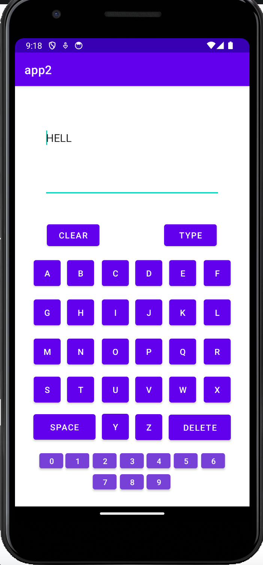 

**Clear**

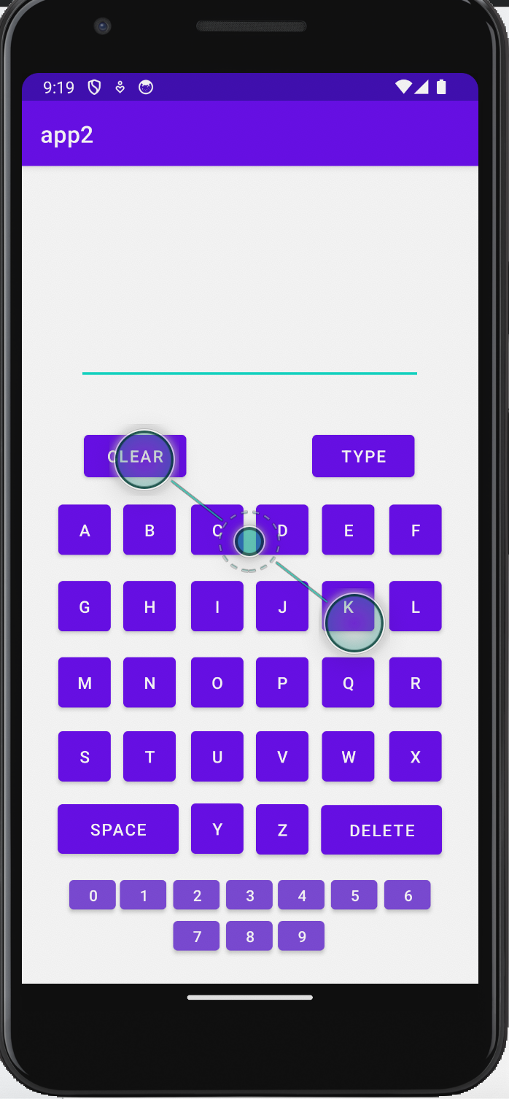

**Result**

The result of the exercise is an Android mobile application with a virtual keyboard, using multiple activities with intents for navigation, and a TextView to display typed content.

**Best Practices**

1. Developed a responsive, scrollable application that can be viewed on devices with varying screen sizes.

2. Used standard naming conventions to make the application easier to comprehend.

**Learning outcomes:**

* ● An android app was designed and implemented.

● A keyboard was designed for a mobile application.

**ASSIGNMENT 3**

* **Application using graphical primitives**
* **September 17, 2023**

**Question**

Design a CAR using Shape drawables with the help of relevant shapes such as Line, Circle, Rectangle and Arc.

a. Move the car forward by pressing forward button so that car moves from a  
predefined starting point to the predefined endpoint.

b. On pressing the backward button, rotate the car to 180 degrees from the current point to the starting point.  
c. Implement a Tap-to-zoom animation on any image  
d. Implement the Card flipping animation.

**Algorithm**

Initialize carRotation to 90 (degrees)

Initialize fd to 1 (forward direction)

Initialize isZoomed to false (not zoomed)

Declare carImageView as the car's image

Declare forwardButton as the button for moving forward

Declare backwardButton as the button for moving backward

In the onCreate method:

- Set up the user interface by loading the layout from activity_main.xml

- Get references to the carImageView, forwardButton, and backwardButton

When forwardButton is clicked:

- If the car is currently facing backward (fd equals 0):

- Rotate the car 180 degrees to face forward

- Update carRotation to reflect the new rotation

- Change the direction to forward (fd to 1)

- Get the current Y position of the carImageView

- Move the carImageView 20 units down (simulating forward movement)

When backwardButton is clicked:

- If the car is currently facing forward (fd equals 1):

- Rotate the car 180 degrees to face backward

- Update carRotation to reflect the new rotation

- Change the direction to backward (fd to 0)

- Get the current Y position of the carImageView

- Move the carImageView 20 units up (simulating backward movement)

When carImageView is clicked:

- If the car is not zoomed in:

- Zoom in by scaling the carImageView to 2 times its size

- Set isZoomed to true

- If the car is already zoomed in:

- Zoom out by resetting the scale to its original size (1.0)

- Set isZoomed to false

**Source Code**

**//MainActivity.java**

package com.example.app3;

import androidx.appcompat.app.AppCompatActivity;

import android.os.Bundle;

import android.view.View;

import android.widget.Button;

import android.widget.ImageView;

public class MainActivity extends AppCompatActivity {

@Override

protected void onCreate(Bundle savedInstanceState) {

super.onCreate(savedInstanceState);

setContentView(R.layout.*activity_main*);

ImageView carImageView;

Button forwardButton;

Button backwardButton;

final float[] carRotation = {90};

final int[] fd = {1};

final boolean[] isZoomed = {false};

carImageView = findViewById(R.id.*imageView*);

forwardButton = findViewById(R.id.*forward*);

backwardButton = findViewById(R.id.*backward*);

forwardButton.setOnClickListener(new View.OnClickListener() {

@Override

public void onClick(View v) {

if (fd[0] == 0){

carRotation[0] += 180;

carImageView.setRotation(carRotation[0]);

fd[0] = 1;

}

float currentY = carImageView.getTranslationY();

carImageView.setTranslationY(currentY+20);

}

});

backwardButton.setOnClickListener(new View.OnClickListener() {

@Override

public void onClick(View v) {

if (fd[0] == 1) {

carRotation[0] += 180;

carImageView.setRotation(carRotation[0]);

fd[0] = 0;

}

float currentY = carImageView.getTranslationY();

carImageView.setTranslationY(currentY-20);

}

});

carImageView.setOnClickListener(new View.OnClickListener() {

@Override

public void onClick(View v) {

if (isZoomed[0]) {

// Zoom out

carImageView.setScaleX(1.0f);

carImageView.setScaleY(1.0f);

isZoomed[0] = false;

} else {

// Zoom in

carImageView.setScaleX(2.0f);

carImageView.setScaleY(2.0f);

isZoomed[0] = true;

}

}

});

}

}

**//activity_main.xml**

<?xml version="1.0" encoding="utf-8"?>

<androidx.constraintlayout.widget.ConstraintLayout xmlns:android="http://schemas.android.com/apk/res/android"

xmlns:app="http://schemas.android.com/apk/res-auto"

xmlns:tools="http://schemas.android.com/tools"

android:layout_width="match_parent"

android:layout_height="match_parent"

tools:context=".MainActivity">

<!-- activity_main.xml -->

<ImageView

android:id="@+id/imageView"

android:layout_width="125dp"

android:layout_height="167dp"

android:rotation="90"

app:layout_constraintBottom_toBottomOf="parent"

app:layout_constraintEnd_toEndOf="parent"

app:layout_constraintHorizontal_bias="0.646"

app:layout_constraintStart_toStartOf="parent"

app:layout_constraintTop_toTopOf="parent"

app:layout_constraintVertical_bias="0.028"

app:srcCompat="@drawable/car" />

<Button

android:id="@+id/forward"

android:layout_width="wrap_content"

android:layout_height="wrap_content"

android:rotation="90"

android:text="Forward"

app:layout_constraintBottom_toBottomOf="parent"

app:layout_constraintEnd_toEndOf="parent"

app:layout_constraintHorizontal_bias="0.052"

app:layout_constraintStart_toStartOf="parent"

app:layout_constraintTop_toTopOf="parent"

app:layout_constraintVertical_bias="0.279" />

<Button

android:id="@+id/backward"

android:layout_width="wrap_content"

android:layout_height="wrap_content"

android:rotation="90"

android:text="backward"

app:layout_constraintBottom_toBottomOf="parent"

app:layout_constraintEnd_toEndOf="parent"

app:layout_constraintHorizontal_bias="0.017"

app:layout_constraintStart_toStartOf="parent"

app:layout_constraintTop_toTopOf="parent"

app:layout_constraintVertical_bias="0.775" />

</androidx.constraintlayout.widget.ConstraintLayout>

**//car.xml**  
<?xml version="1.0" encoding="utf-8"?>

<layer-list xmlns:android="http://schemas.android.com/apk/res/android" >

<item android:top="25dp" android:left="40dp" android:bottom="150dp" android:right="40dp">

<shape xmlns:android="http://schemas.android.com/apk/res/android"

android:shape="rectangle">

<corners

android:radius="10dp" />

<gradient

android:angle="45"

android:endColor="#990000"

android:startColor="#4d0000"

android:type="linear" />

<!--If your shape requires only one solid color-->

<!--<solid

android:color="#FFFFFF" />-->

<size

android:width="82dp"

android:height="41dp" />

</shape>

</item>

<item android:top="30dp" android:left="45dp" android:bottom="150dp" android:right="45dp">

<shape xmlns:android="http://schemas.android.com/apk/res/android"

android:shape="rectangle">

<corners

android:radius="5dp" />

<gradient

android:angle="0"

android:endColor="#173d73"

android:startColor="#6fa1e8"

android:type="linear" />

<!--If your shape requires only one solid color-->

<!--<solid

android:color="#FFFFFF" />-->

<size

android:width="82dp"

android:height="41dp" />

</shape>

</item>

<item android:top="30dp" android:left="90dp" android:bottom="150dp" android:right="90dp" >

<shape xmlns:android="http://schemas.android.com/apk/res/android"

android:shape="rectangle">

<gradient

android:angle="45"

android:endColor="#730303"

android:startColor="#730303"

android:type="linear" />

<!--If your shape requires only one solid color-->

<!--<solid

android:color="#FFFFFF" />-->

<size

android:width="4dp"

android:height="41dp" />

</shape>

</item>

<item android:top="60dp" android:left="0dp" android:bottom="115dp" android:right="0dp" >

<shape xmlns:android="http://schemas.android.com/apk/res/android"

android:shape="rectangle">

<corners

android:radius="10dp" />

<gradient

android:angle="45"

android:endColor="#990000"

android:startColor="#4d0000"

android:type="linear" />

<!--If your shape requires only one solid color-->

<!--<solid

android:color="#FFFFFF" />-->

<size

android:width="128dp"

android:height="41dp" />

</shape>

</item>

<item android:top="80dp" android:left="110dp" android:bottom="100dp" android:right="30dp">

<shape

xmlns:android="http://schemas.android.com/apk/res/android"

android:shape="oval">

<solid

android:color="#1B1A1A"/>

<size

android:width="50dp"

android:height="50dp"/>

</shape>

</item>

<item android:top="80dp" android:left="30dp" android:bottom="100dp" android:right="110dp">

<shape

xmlns:android="http://schemas.android.com/apk/res/android"

android:shape="oval">

<solid

android:color="#000000"/>

<size

android:width="50dp"

android:height="50dp"/>

</shape>

</item>

<item android:top="90dp" android:left="120dp" android:bottom="110dp" android:right="40dp">

<shape

xmlns:android="http://schemas.android.com/apk/res/android"

android:shape="oval">

<solid

android:color="#323131"/>

<size

android:width="30dp"

android:height="30dp"/>

</shape>

</item>

<item android:top="90dp" android:left="40dp" android:bottom="110dp" android:right="120dp">

<shape

xmlns:android="http://schemas.android.com/apk/res/android"

android:shape="oval">

<solid

android:color="#323131"/>

<size

android:width="30dp"

android:height="30dp"/>

</shape>

</item>

<item android:top="70dp" android:left="170dp" android:bottom="145dp" android:right="10dp">

<shape

xmlns:android="http://schemas.android.com/apk/res/android"

android:shape="oval">

<solid

android:color="#FFD350"/>

<size

android:width="15dp"

android:height="15dp"/>

</shape>

</item>

</layer-list>

**Output Screenshots**

* 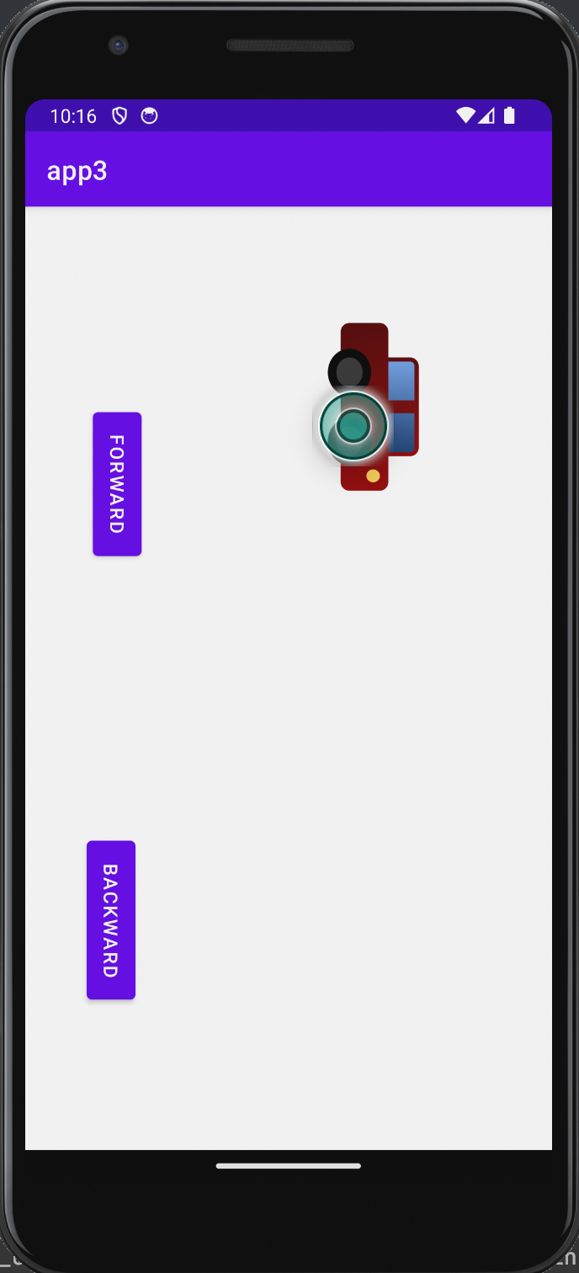

***Forward Button***

* 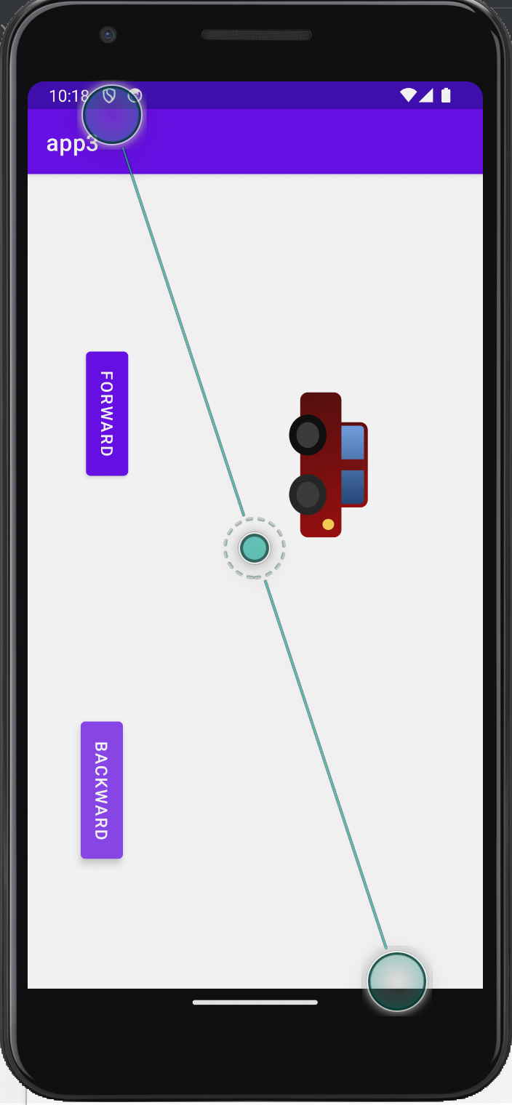

***Backward Button***

* 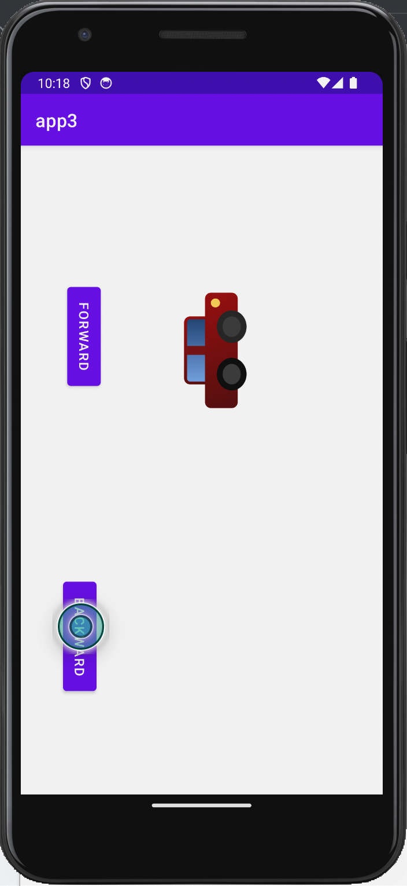

***Tap-to-zoom***

* 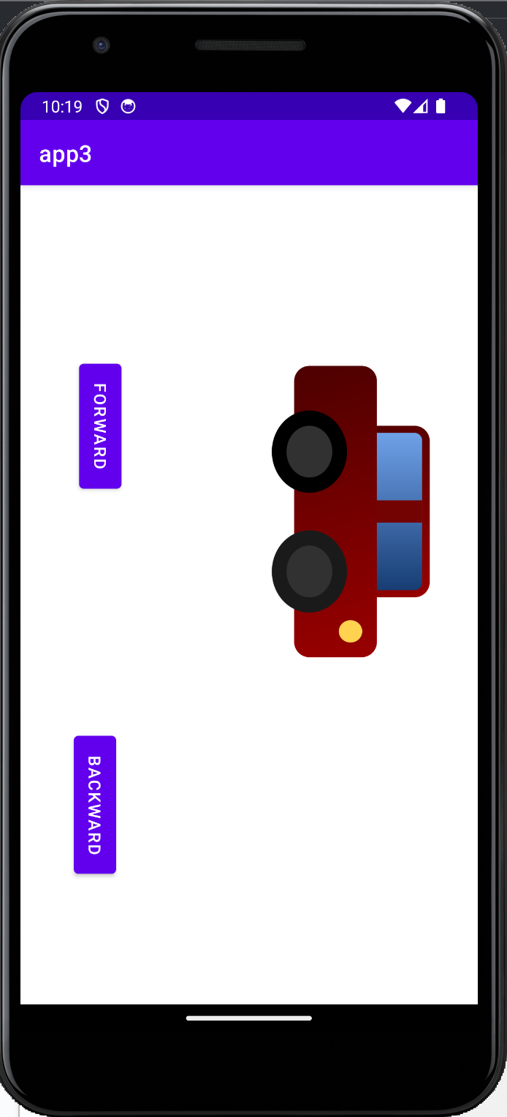

**Source Code**

**//MainActivity.java**

package com.example.app3b;

import androidx.appcompat.app.AppCompatActivity;

import androidx.cardview.widget.CardView;

import android.os.Bundle;

import android.view.View;

import android.view.animation.Animation;

import android.view.animation.AnimationUtils;

import android.widget.ImageView;

public class MainActivity extends AppCompatActivity {

private CardView cardView;

private boolean isFront = true;

@Override

protected void onCreate(Bundle savedInstanceState) {

super.onCreate(savedInstanceState);

setContentView(R.layout.*activity_main*);

cardView = findViewById(R.id.*cardView*);

cardView.setOnClickListener(new View.OnClickListener() {

@Override

public void onClick(View v) {

flipCard();

}

});

}

void flipCard() {

Animation flipAnimation;

if (isFront) {

// Flip to the back

flipAnimation = AnimationUtils.*loadAnimation*(this, R.anim.*flip_out*);

findViewById(R.id.*frontLayout*).setVisibility(View.*GONE*);

findViewById(R.id.*backLayout*).setVisibility(View.*VISIBLE*);

} else {

// Flip to the front

flipAnimation = AnimationUtils.*loadAnimation*(this, R.anim.*flip_in*);

findViewById(R.id.*frontLayout*).setVisibility(View.*VISIBLE*);

findViewById(R.id.*backLayout*).setVisibility(View.*GONE*);

}

cardView.startAnimation(flipAnimation);

isFront = !isFront;

}

}

**//Activity_main.xml**

<?xml version="1.0" encoding="utf-8"?>

<androidx.cardview.widget.CardView xmlns:android="http://schemas.android.com/apk/res/android"

xmlns:app="http://schemas.android.com/apk/res-auto"

android:id="@+id/cardView"

android:layout_width="match_parent"

android:layout_height="match_parent"

app:cardBackgroundColor="#FFFFFF"

app:cardCornerRadius="8dp"

app:cardElevation="8dp"

app:cardUseCompatPadding="true">

<LinearLayout

android:id="@+id/frontLayout"

android:layout_width="match_parent"

android:layout_height="match_parent"

android:orientation="vertical">

<ImageView

android:id="@+id/imageViewFront"

android:layout_width="match_parent"

android:layout_height="match_parent"

android:src="@drawable/front"

android:scaleType="fitXY" />

</LinearLayout>

<!-- Back Layout -->

<LinearLayout

android:id="@+id/backLayout"

android:layout_width="match_parent"

android:layout_height="match_parent"

android:orientation="vertical"

android:visibility="gone">

<!-- Place your back content here -->

<ImageView

android:id="@+id/imageViewBack"

android:layout_width="match_parent"

android:layout_height="match_parent"

android:src="@drawable/back"

android:scaleType="fitXY" />

</LinearLayout>

</androidx.cardview.widget.CardView>

**//flip_out.xml**

<?xml version="1.0" encoding="utf-8"?>

<set xmlns:android="http://schemas.android.com/apk/res/android">

<rotate

android:fromDegrees="0"

android:toDegrees="180"

android:duration="500"

android:pivotX="50%"

android:pivotY="50%"

android:fillAfter="true" />

</set>

**//flip_in.xml**

<?xml version="1.0" encoding="utf-8"?>

<set xmlns:android="http://schemas.android.com/apk/res/android">

<rotate

android:fromDegrees="180"

android:toDegrees="0"

android:duration="500"

android:pivotX="50%"

android:pivotY="50%"

android:fillAfter="true" />

</set>

**Output Screenshot**

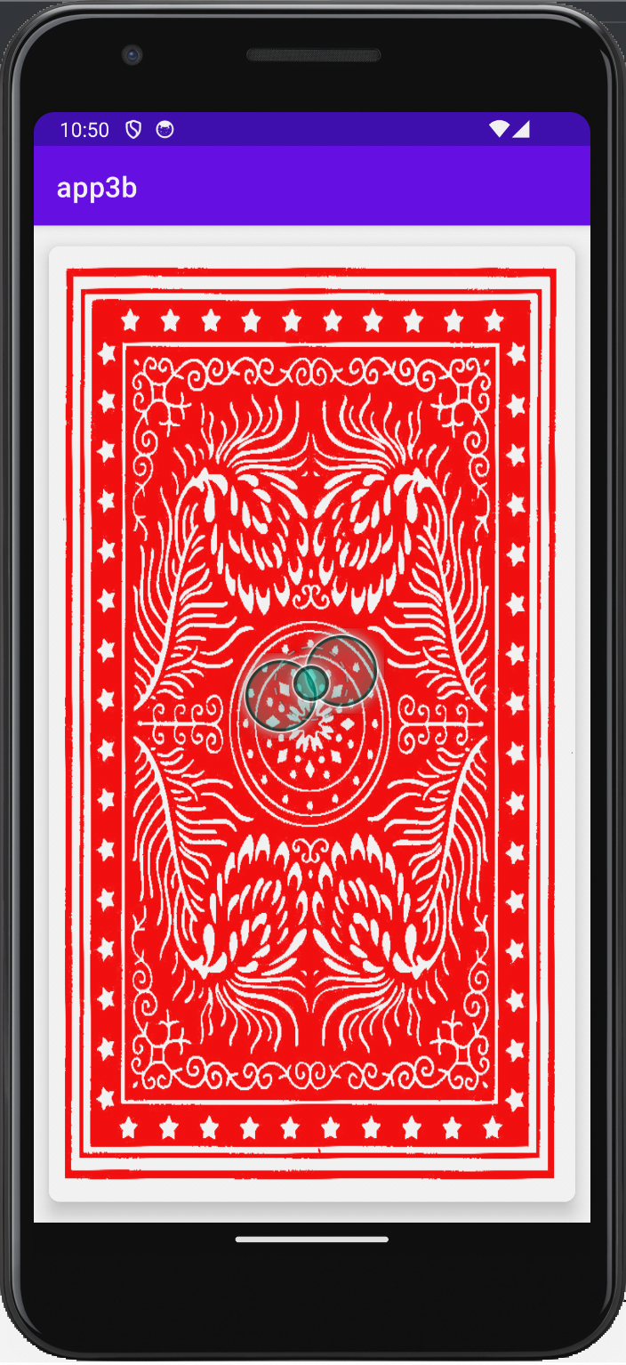 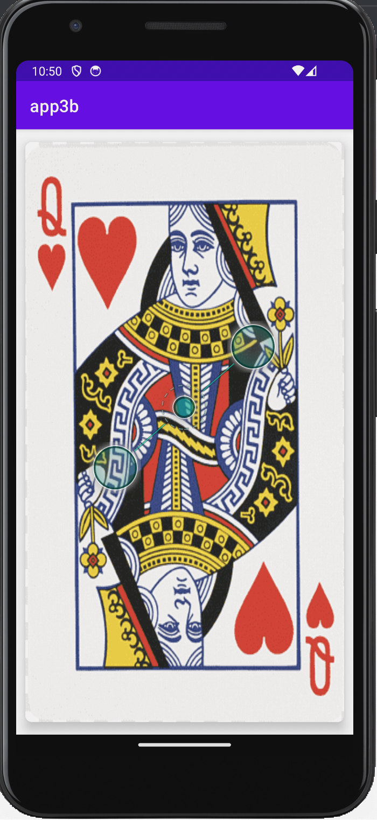

**Result**

The result of the exercise is an Android mobile application with operations involving graphical elements, using graphical primitives such as the drawable class to design appropriate assets.

**Best Practices**

1. Developed a responsive, scrollable application that can be viewed on devices with varying screen sizes.

2. Used standard naming conventions to make the application easier to comprehend.

**Learning outcomes:**

* ● An android app was designed and implemented.
* ● Graphical primitives were experimented with for a mobile application.

**ASSIGNMENT 4**

**Android Application Development using Database**

**October 10, 2023**

**Question**

Develop a Product information application in Android that enables to perform CRUD

operations on data stored in SQLite Database.

In main activity display the following buttons: Create, Insert, Update, Delete, Retrieve, Retrieve All

1. On clicking Create Button, create a new database to store the Product details. (Use

SQLite Database)

a. Product ID (Make this field as primary key)

b. Product Name

c. Product Brand

d. Description

e. Product Price

2. On Clicking Insert, move to a new view which contains the following details: (Insert

new Product to the database)

a. Product ID (EditText-Validation checking- 4 digit Numbers)

b. Product Name (Spinner)

c. Product Brand (RadioButton)

d. Description (EditText-Alphanumeric characters)

e. Product Price (EditText-Validation checking Numbers)

f. Submit (Button) – On press, Insert the data into the database.

3. On clicking Update, move to a new view which contains above details and Update

Product Price using Product ID.

4. On clicking Delete, Delete the whole row in the table by Product ID.

5. On clicking Retrieve, Retrieve the product using Product ID.

6. On clicking Retrieve All, retrieve the details of all the products in a particular brand.

**Algorithm**

1. Create a New Android Project in Android Studio.

2. Design the Layouts:

- Design activity_main.xml with buttons: Insert, Update, Delete, Retrieve, and Retrieve All.

- Create layout files for Insert, Update, Delete, Retrieve, and Retrieve All activities.

3. Create Database Helper Class:

- Create a SQLite database helper class that extends SQLiteOpenHelper.

- Define the database schema with a table for products, including columns: Product ID (primary key), Product Name, Product Brand, Description, and Product Price.

4. Create a CRUD Class:

- Implement a class to handle CRUD operations (Create, Read, Update, Delete) on the database.

- Define methods for inserting, updating, deleting, retrieving a single product by ID, and retrieving all products in a specific brand.

5. Main Activity (MainActivity.java):

- Initialize the database helper and the CRUD class.

- Initialise a new database to store product details if it doesn't exist using SQLiteOpenHelper.

- Set click listeners for the buttons (Insert, Update, Delete, Retrieve, Retrieve All).

- In the button click listeners, use Intents to navigate to the respective activities (Insert, Update, Delete, Retrieve, Retrieve All).

6. Insert Activity:

- In the "Insert" activity, design the layout for inputting product details.

- Implement validation for Product ID (4-digit numbers) and Product Price (numeric).

- Insert the entered data into the database when the "Submit" button is pressed.

7. Update Activity:

- In the "Update" activity, design the layout similar to the Insert activity with fields for updating the Product Price.

- Implement validation for Product ID and Price.

- Update the Product Price in the database for the given Product ID.

8. Delete Activity:

- Create a "Delete" activity for deleting a product by entering the Product ID.

- Implement validation for Product ID.

- Delete the product with the specified Product ID when the "Delete" button is pressed.

9. Retrieve Activity:

- Create a "Retrieve" activity for fetching a single product by entering the Product ID.

- Design the layout to input the Product ID.

- On button click, fetch and display the product details by Product ID.

10. Retrieve All Activity:

- Create a "Retrieve All" activity to display a list of all products.

- Fetch and display the products.

11. Testing:

- Test your application on an Android emulator or a physical Android device to ensure it works as expected.

**Source Code**

**//MainActivity.java**

package com.example.app4;

import androidx.appcompat.app.AppCompatActivity;

import android.content.Intent;

import android.os.Bundle;

import android.view.View;

import android.widget.Button;

public class MainActivity extends AppCompatActivity {

Button insert, update, retrieveAll, retrieve, delete;

myDbHelper db;

@Override

protected void onCreate(Bundle savedInstanceState) {

super.onCreate(savedInstanceState);

setContentView(R.layout.*activity_main*);

db = new myDbHelper(this);

insert = findViewById(R.id.*insert_menu*);

insert.setOnClickListener(new View.OnClickListener() {

@Override

public void onClick(View v) {

openNewInsertActivity();

}

});

update = findViewById(R.id.*update_menu*);

update.setOnClickListener(new View.OnClickListener() {

@Override

public void onClick(View v) {

openNewUpdateActivity();

}

});

retrieveAll = findViewById(R.id.*retrieveall_menu*);

retrieveAll.setOnClickListener(new View.OnClickListener() {

@Override

public void onClick(View v) {

openNewRetrieveAllActivity();

}

});

retrieve = findViewById(R.id.*retrieve_button*);

retrieve.setOnClickListener(new View.OnClickListener() {

@Override

public void onClick(View v) {

openNewRetrieveActivity();

}

});

delete = findViewById(R.id.*delete_button*);

delete.setOnClickListener(new View.OnClickListener() {

@Override

public void onClick(View v) {

openNewDeleteActivity();

}

});

}

public void openNewInsertActivity(){

Intent intent = new Intent(this, InsertActivity.class);

startActivity(intent);

}

public void openNewUpdateActivity(){

Intent intent = new Intent(this, UpdateActivity.class);

startActivity(intent);

}

public void openNewRetrieveAllActivity(){

Intent intent = new Intent(this, RetrieveAllActivity.class);

startActivity(intent);

}

public void openNewRetrieveActivity(){

Intent intent = new Intent(this, RetrieveActivity.class);

startActivity(intent);

}

public void openNewDeleteActivity(){

Intent intent = new Intent(this, DeleteActivity.class);

startActivity(intent);

}

}

**//myDBHelper.java**

package com.example.app4;

import android.content.ContentValues;

import android.content.Context;

import android.database.Cursor;

import android.database.sqlite.SQLiteDatabase;

import android.database.sqlite.SQLiteOpenHelper;

import java.util.ArrayList;

public class myDbHelper extends SQLiteOpenHelper {

public static final String *DATABASE_NAME* = "App4DB.db";

public static final String *PRODUCT_TABLE_NAME* = "products";

public static final String *PRODUCTS_COLUMN_ID* = "id";

public static final String *PRODUCTS_COLUMN_NAME* = "name";

public static final String *PRODUCTS_COLUMN_BRAND* = "brand";

public static final String *PRODUCTS_COLUMN_DESC* = "description";

public static final String *PRODUCTS_COLUMN_PRICE* = "price";

public myDbHelper(Context context) {

super(context,*DATABASE_NAME*,null,1);

}

@Override

public void onCreate(SQLiteDatabase db) {

db.execSQL(

"create table products " +

"(id integer primary key, name text, brand text, description text, price text)"

);

}

@Override

public void onUpgrade(SQLiteDatabase db, int oldVersion, int newVersion) {

db.execSQL("DROP TABLE IF EXISTS products");

onCreate(db);

}

public boolean insertProduct(String id, String name, String brand, String desc, String price) {

SQLiteDatabase db = this.getWritableDatabase();

ContentValues contentValues = new ContentValues();

contentValues.put("name", name);

contentValues.put("id", id);

contentValues.put("brand", brand);

contentValues.put("description", desc);

contentValues.put("price", price);

db.insert("products", null, contentValues);

return true;

}

public boolean updateProduct(String pid, String newPrice) {

SQLiteDatabase db = this.getWritableDatabase();

ContentValues contentValues = new ContentValues();

contentValues.put("price", newPrice);

String sql = "UPDATE products SET price = " + newPrice + "WHERE id = " + pid;

db.update("products", contentValues, "id=?", new String[]{pid});

return true;

}

public ArrayList<ProductModal> readAll() {

SQLiteDatabase db = this.getWritableDatabase();

ContentValues contentValues = new ContentValues();

// on below line we are creating a cursor with query to read data from database.

Cursor cursorProducts = db.rawQuery("SELECT * FROM " + "products", null);

// on below line we are creating a new array list.

ArrayList<ProductModal> productModalArrayList = new ArrayList<>();

if (cursorProducts.moveToFirst()) {

do {

// on below line we are adding the data from

// cursor to our array list.

productModalArrayList.add(new ProductModal(

cursorProducts.getString(0),

cursorProducts.getString(1),

cursorProducts.getString(2),

cursorProducts.getString(3),

cursorProducts.getString(4)));

} while (cursorProducts.moveToNext());

// moving our cursor to next.

}

// at last closing our cursor

// and returning our array list.

cursorProducts.close();

return productModalArrayList;

}

public boolean deleteProduct(String PID) {

SQLiteDatabase db = this.getWritableDatabase();

db.delete(*PRODUCT_TABLE_NAME*, "id=?", new String[]{PID});

db.close();

return true;

}

}

**//ProductModal.java**

package com.example.app4;

public class ProductModal {

private String productName;

private String pid;

private String brand;

private String desc;

private String price;

// creating getter and setter methods

public String getProductName() {

return productName;

}

public void setProductName(String productName) {

this.productName = productName;

}

public String getPid() {

return pid;

}

public void setPid(String pid) {

this.pid = pid;

}

public String getBrand() {

return brand;

}

public void setBrand(String brand) {

this.brand = brand;

}

public String getDesc() {

return desc;

}

public void setDesc(String desc) {

this.desc = desc;

}

public String getPrice() {

return price;

}

public void setPrice(String price) {

this.price = price;

}

// constructor

public ProductModal(String pid,

String productName,

String brand,

String desc,

String price) {

this.productName = productName;

this.pid = pid;

this.desc = desc;

this.brand = brand;

this.price = price;

}

}

**//InsertActivity.java**

package com.example.app4;

import androidx.appcompat.app.AppCompatActivity;

import android.os.Bundle;

import android.view.View;

import android.widget.Button;

import android.widget.EditText;

import android.widget.TextView;

public class InsertActivity extends AppCompatActivity {

Button insertDetails;

EditText input_text;

TextView message_insert;

myDbHelper db;

String message;

@Override

protected void onCreate(Bundle savedInstanceState) {

super.onCreate(savedInstanceState);

setContentView(R.layout.*activity_insert*);

insertDetails = findViewById(R.id.*insertDetails_button*);

db = new myDbHelper(this);

insertDetails.setOnClickListener(new View.OnClickListener() {

@Override

public void onClick(View v) {

input_text = findViewById(R.id.*id_input*);

String id = input_text.getText().toString();

input_text = findViewById(R.id.*name_input*);

String name = input_text.getText().toString();

input_text = findViewById(R.id.*brand_input*);

String brand = input_text.getText().toString();

input_text = findViewById(R.id.*desc_input*);

String desc = input_text.getText().toString();

input_text = findViewById(R.id.*price_input*);

String price = input_text.getText().toString();

boolean check = db.insertProduct(id, name, brand, desc, price);

message_insert = findViewById(R.id.*statusInsert*);

if (check){

message_insert.setText("Inserted into Database");

}

else{

message_insert.setText("Error: Cannot be inserted");

}

}

});

}

}

**//UpdateActivity.java**

package com.example.app4;

import android.os.Bundle;

import android.view.View;

import android.widget.Button;

import android.widget.EditText;

import android.widget.TextView;

import androidx.annotation.Nullable;

import androidx.appcompat.app.AppCompatActivity;

public class UpdateActivity extends AppCompatActivity {

Button updateDetails;

EditText input_text;

TextView message_update;

myDbHelper db;

String message;

@Override

protected void onCreate(@Nullable Bundle savedInstanceState) {

super.onCreate(savedInstanceState);

setContentView(R.layout.activity_update);

updateDetails = findViewById(R.id.update_button);

db = new myDbHelper(this);

message_update = findViewById(R.id.status_update);

updateDetails.setOnClickListener(new View.OnClickListener() {

@Override

public void onClick(View v) {

input_text = findViewById(R.id.PID_value_update);

String pid = input_text.getText().toString();

input_text = findViewById(R.id.Price_New_Update);

String newPrice = input_text.getText().toString();

boolean check = db.updateProduct(pid, newPrice);

if (check){

message_update.setText("Updated Database");

}

else{

message_update.setText("Error: Could not update Database");

}

}

});

}

}

**//DeleteActivity.java**

package com.example.app4;

import android.os.Bundle;

import android.view.View;

import android.widget.Button;

import android.widget.EditText;

import android.widget.TextView;

import androidx.annotation.Nullable;

import androidx.appcompat.app.AppCompatActivity;

public class DeleteActivity extends AppCompatActivity {

Button updateDetails;

EditText input_text;

TextView message_delete;

myDbHelper db;

String message;

@Override

protected void onCreate(@Nullable Bundle savedInstanceState) {

super.onCreate(savedInstanceState);

setContentView(R.layout.activity_delete);

updateDetails = findViewById(R.id.delete_Button);

db = new myDbHelper(this);

message_delete = findViewById(R.id.status_delete);

updateDetails.setOnClickListener(new View.OnClickListener() {

@Override

public void onClick(View v) {

input_text = findViewById(R.id.PID_deleteInput);

String pid = input_text.getText().toString();

boolean check = db.deleteProduct(pid);

if (check){

message_delete.setText("Deleted from Database");

}

else{

message_delete.setText("Error: Could not delete from Database");

}

}

});

}

}

**//RetrieveActivity.java**

package com.example.app4;

import android.os.Bundle;

import android.view.View;

import android.widget.Button;

import android.widget.EditText;

import android.widget.TextView;

import androidx.annotation.Nullable;

import androidx.appcompat.app.AppCompatActivity;

import java.util.ArrayList;

public class RetrieveActivity extends AppCompatActivity {

Button retrieve;

myDbHelper db;

TextView message_retrieve;

TextView allResults;

TextView checkElement;

@Override

protected void onCreate(@Nullable Bundle savedInstanceState) {

super.onCreate(savedInstanceState);

setContentView(R.layout.activity_retrieve);

db = new myDbHelper(this);

message_retrieve = findViewById(R.id.status_retrieve);

allResults = findViewById(R.id.retrieved);

retrieve = findViewById(R.id.retrieve_Button);

checkElement = findViewById(R.id.PID_retrieveInput);

retrieve.setOnClickListener(new View.OnClickListener() {

@Override

public void onClick(View v) {

String printResult = "";

int flag = 0;

allResults.setText("");

ArrayList<ProductModal> result = db.readAll();

for(ProductModal product: result){

String checkPID = product.getPid();

String check = checkElement.getText().toString();

if (checkPID.equals(check)) {

printResult = "";

printResult += "PID: ";

printResult += product.getPid();

printResult += "\nProduct Name: ";

printResult += product.getProductName();

printResult += "\nBrand: ";

printResult += product.getBrand();

printResult += "\nDescription: ";

printResult += product.getDesc();

printResult += "\nPrice: $";

printResult += product.getPrice();

printResult += "\n\n";

flag = 1;

}

}

allResults.setText(printResult);

if (flag == 1){

message_retrieve.setText("Entry found.");

}

else{

message_retrieve.setText("Error: Entry not found.");

}

}

});

}

}

**//RetrieveAllActivity.java**

package com.example.app4;

import android.os.Bundle;

import android.view.View;

import android.widget.Button;

import android.widget.TextView;

import androidx.annotation.Nullable;

import androidx.appcompat.app.AppCompatActivity;

import java.util.ArrayList;

public class RetrieveAllActivity extends AppCompatActivity {

Button retrieveAll;

myDbHelper db;

TextView message_retrieveAll;

TextView allResults;

@Override

protected void onCreate(@Nullable Bundle savedInstanceState) {

super.onCreate(savedInstanceState);

setContentView(R.layout.activity_retrieveall);

db = new myDbHelper(this);

message_retrieveAll = findViewById(R.id.status_retrieveAll);

allResults = findViewById(R.id.allRetrieved);

retrieveAll = findViewById(R.id.retrieveAll_button);

retrieveAll.setOnClickListener(new View.OnClickListener() {

@Override

public void onClick(View v) {

String printResult = "";

allResults.setText("");

ArrayList<ProductModal> result = db.readAll();

for(ProductModal product: result){

//printResult = "";

printResult += "PID: ";

printResult += product.getPid();

printResult += "\nProduct Name: ";

printResult += product.getProductName();

printResult += "\nBrand: ";

printResult += product.getBrand();

printResult += "\nDescription: ";

printResult += product.getDesc();

printResult += "\nPrice: $";

printResult += product.getPrice();

printResult += "\n\n";

}

allResults.setText(printResult);

message_retrieveAll.setText("Entries read");

}

});

}

}

**//activity_main.xml**

<?xml version="1.0" encoding="utf-8"?>

<androidx.constraintlayout.widget.ConstraintLayout xmlns:android="http://schemas.android.com/apk/res/android"

xmlns:app="http://schemas.android.com/apk/res-auto"

xmlns:tools="http://schemas.android.com/tools"

android:layout_width="match_parent"

android:layout_height="match_parent"

tools:context=".MainActivity">

<ScrollView

android:layout_width="416dp"

android:layout_height="732dp"

app:layout_constraintBottom_toBottomOf="parent"

app:layout_constraintEnd_toEndOf="parent"

app:layout_constraintStart_toStartOf="parent"

app:layout_constraintTop_toTopOf="parent"

>

<LinearLayout

android:layout_width="match_parent"

android:layout_height="wrap_content"

android:orientation="vertical"

android:padding="30dp">

<TableLayout

android:layout_width="match_parent"

android:layout_height="match_parent"

>

<TableRow

android:layout_width="match_parent"

android:layout_height="match_parent"

android:gravity="center_horizontal"

android:layout_margin="10dp">

<TextView

android:id="@+id/main_title"

android:layout_width="wrap_content"

android:layout_height="wrap_content"

android:layout_marginBottom="10dp"

android:fontFamily="serif"

android:text="Product Registration System"

android:textSize="20sp" />

</TableRow>

<TableRow

android:layout_width="match_parent"

android:layout_height="match_parent"

android:gravity="center_horizontal"

android:layout_marginBottom="10dp">

<Button

android:id="@+id/insert_menu"

android:layout_width="wrap_content"

android:layout_height="wrap_content"

android:text="Insert" />

</TableRow>

<TableRow

android:layout_width="match_parent"

android:layout_height="match_parent"

android:gravity="center_horizontal"

android:layout_marginBottom="10dp">

<Button

android:id="@+id/update_menu"

android:layout_width="wrap_content"

android:layout_height="wrap_content"

android:text="Update" />

</TableRow>

<TableRow

android:layout_width="match_parent"

android:layout_height="match_parent"

android:gravity="center_horizontal"

android:layout_marginBottom="10dp">

<Button

android:id="@+id/delete_button"

android:layout_width="wrap_content"

android:layout_height="wrap_content"

android:text="Delete" />

</TableRow>

<TableRow

android:layout_width="match_parent"

android:layout_height="match_parent"

android:gravity="center_horizontal"

android:layout_marginBottom="10dp">

<Button

android:id="@+id/retrieve_button"

android:layout_width="wrap_content"

android:layout_height="wrap_content"

android:text="Retrieve" />

</TableRow>

<TableRow

android:layout_width="match_parent"

android:layout_height="match_parent"

android:gravity="center_horizontal"

android:layout_marginBottom="10dp">

<Button

android:id="@+id/retrieveall_menu"

android:layout_width="wrap_content"

android:layout_height="wrap_content"

android:text="Retrieve All" />

</TableRow>

</TableLayout>

</LinearLayout>

</ScrollView>

</androidx.constraintlayout.widget.ConstraintLayout>

**//activity_insert.xml**

<?xml version="1.0" encoding="utf-8"?>

<androidx.constraintlayout.widget.ConstraintLayout xmlns:android="http://schemas.android.com/apk/res/android"

xmlns:app="http://schemas.android.com/apk/res-auto"

xmlns:tools="http://schemas.android.com/tools"

android:layout_width="match_parent"

android:layout_height="match_parent"

tools:context=".MainActivity">

<ScrollView

android:layout_width="416dp"

android:layout_height="732dp"

app:layout_constraintBottom_toBottomOf="parent"

app:layout_constraintEnd_toEndOf="parent"

app:layout_constraintStart_toStartOf="parent"

app:layout_constraintTop_toTopOf="parent"

>

<LinearLayout

android:layout_width="match_parent"

android:layout_height="wrap_content"

android:orientation="vertical"

android:padding="30dp">

<TableLayout

android:layout_width="match_parent"

android:layout_height="match_parent"

>

<TableRow

android:layout_width="match_parent"

android:layout_height="match_parent"

android:gravity="center_horizontal"

android:layout_marginTop="20dp"

android:layout_marginBottom="40dp">

<TextView

android:id="@+id/main_title"

android:layout_width="wrap_content"

android:layout_height="wrap_content"

android:layout_marginBottom="10dp"

android:fontFamily="serif"

android:text="Insert new Product into database"

android:textSize="20sp" />

</TableRow>

<TableRow

android:layout_width="0dp"

android:layout_height="match_parent"

android:layout_marginBottom="10dp">

<TextView

android:id="@+id/id_title"

android:layout_width="wrap_content"

android:layout_height="wrap_content"

android:layout_weight="1"

android:fontFamily="serif"

android:text="ID:"

android:textSize="15sp" />

<EditText

android:id="@+id/id_input"

android:layout_width="wrap_content"

android:layout_height="wrap_content"

android:ems="12"

android:fontFamily="serif"

android:textSize="15sp"

android:inputType="textPersonName"

tools:ignore="TouchTargetSizeCheck" />

</TableRow>

<TableRow

android:layout_width="0dp"

android:layout_height="match_parent"

android:layout_marginBottom="10dp">

<TextView

android:id="@+id/name_title"

android:layout_width="wrap_content"

android:layout_height="wrap_content"

android:layout_weight="1"

android:fontFamily="serif"

android:text="Name:"

android:textSize="15sp" />

<EditText

android:id="@+id/name_input"

android:layout_width="wrap_content"

android:layout_height="wrap_content"

android:ems="12"

android:fontFamily="serif"

android:inputType="textPersonName"

android:textSize="15sp" />

</TableRow>

<TableRow

android:layout_width="match_parent"

android:layout_height="match_parent"

android:layout_marginBottom="10dp">

<TextView

android:id="@+id/brand_title"

android:layout_width="wrap_content"

android:layout_height="wrap_content"

android:layout_weight="1"

android:fontFamily="serif"

android:text="Brand:"

android:textSize="15sp" />

<EditText

android:id="@+id/brand_input"

android:layout_width="wrap_content"

android:layout_height="wrap_content"

android:ems="10"

android:fontFamily="serif"

android:inputType="textPersonName"

android:textSize="15sp" />

</TableRow>

<TableRow

android:layout_width="match_parent"

android:layout_height="match_parent"

android:layout_marginBottom="10dp">

<TextView

android:id="@+id/desc_title"

android:layout_width="wrap_content"

android:layout_height="wrap_content"

android:layout_weight="1"

android:fontFamily="serif"

android:text="Description:"

android:textSize="15sp" />

<EditText

android:id="@+id/desc_input"

android:layout_width="wrap_content"

android:layout_height="wrap_content"

android:ems="12"

android:fontFamily="serif"

android:inputType="textPersonName"

android:textSize="15sp" />

</TableRow>

<TableRow

android:layout_width="match_parent"

android:layout_height="match_parent"

android:layout_marginBottom="10dp">

<TextView

android:id="@+id/price_title"

android:layout_width="wrap_content"

android:layout_height="wrap_content"

android:layout_weight="1"

android:fontFamily="serif"

android:text="Price:"

android:textSize="15sp" />

<EditText

android:id="@+id/price_input"

android:layout_width="wrap_content"

android:layout_height="wrap_content"

android:ems="12"

android:fontFamily="serif"

android:inputType="textPersonName"

android:textSize="15sp" />

</TableRow>

<TableRow

android:layout_width="match_parent"

android:layout_height="match_parent"

android:layout_marginBottom="10dp"

android:gravity = "center_horizontal">

<TextView

android:id="@+id/statusInsert"

android:layout_width="wrap_content"

android:layout_height="wrap_content"

android:textSize="10sp"

android:padding="10dp"

android:gravity="center_horizontal"/>

</TableRow>

<TableRow

android:layout_width="wrap_content"

android:layout_height="match_parent"

android:layout_margin="20dp"

android:gravity="center_horizontal"

android:padding="10dp">

<Button

android:id="@+id/insertDetails_button"

android:layout_width="wrap_content"

android:layout_height="wrap_content"

android:text="Insert" />

</TableRow>

</TableLayout>

</LinearLayout>

</ScrollView>

</androidx.constraintlayout.widget.ConstraintLayout>

**//activity_update.xml**

<?xml version="1.0" encoding="utf-8"?>

<androidx.constraintlayout.widget.ConstraintLayout xmlns:android="http://schemas.android.com/apk/res/android"

xmlns:app="http://schemas.android.com/apk/res-auto"

xmlns:tools="http://schemas.android.com/tools"

android:layout_width="match_parent"

android:layout_height="match_parent"

tools:context=".MainActivity">

<ScrollView

android:layout_width="416dp"

android:layout_height="732dp"

app:layout_constraintBottom_toBottomOf="parent"

app:layout_constraintEnd_toEndOf="parent"

app:layout_constraintStart_toStartOf="parent"

app:layout_constraintTop_toTopOf="parent"

>

<LinearLayout

android:layout_width="match_parent"

android:layout_height="wrap_content"

android:orientation="vertical"

android:padding="30dp">

<TableLayout

android:layout_width="match_parent"

android:layout_height="match_parent">

<TableRow

android:layout_width="match_parent"

android:layout_height="match_parent"

android:gravity="center_horizontal"

android:layout_marginTop="20dp"

android:layout_marginBottom="40dp">

<TextView

android:id="@+id/title_retrieveAll"

android:layout_width="wrap_content"

android:layout_height="wrap_content"

android:layout_marginBottom="10dp"

android:fontFamily="serif"

android:text="Update Product Details"

android:textSize="20sp"/>

</TableRow>

<TableRow

android:layout_width="match_parent"

android:layout_height="match_parent" >

<TextView

android:id="@+id/PID_update"

android:layout_width="wrap_content"

android:layout_height="wrap_content"

android:text="PID to update: "

android:layout_weight="1"

android:fontFamily="serif"

android:textSize="15sp"/>

<EditText

android:id="@+id/PID_value_update"

android:layout_width="wrap_content"

android:layout_height="wrap_content"

android:ems="12"

android:fontFamily="serif"

android:textSize="15sp"

android:inputType="textPersonName"

/>

</TableRow>

<TableRow

android:layout_width="match_parent"

android:layout_height="match_parent" >

<TextView

android:id="@+id/new_price"

android:layout_width="wrap_content"

android:layout_height="wrap_content"

android:text="New Price: "

android:layout_weight="1"

android:fontFamily="serif"

android:textSize="15sp"/>

<EditText

android:id="@+id/Price_New_Update"

android:layout_width="wrap_content"

android:layout_height="wrap_content"

android:inputType="textPersonName"

android:ems="12"

android:fontFamily="serif"

android:textSize="15sp" />

</TableRow>

<TableRow

android:layout_width="match_parent"

android:layout_height="match_parent"

android:gravity="center_horizontal"

android:padding="10dp">

<TextView

android:id="@+id/status_update"

android:layout_width="wrap_content"

android:layout_height="wrap_content"

android:text=""

android:textSize="10sp"

android:gravity="center_horizontal"/>

</TableRow>

<TableRow

android:layout_width="match_parent"

android:layout_height="match_parent"

android:gravity="center_horizontal"

>

<Button

android:id="@+id/update_button"

android:layout_width="wrap_content"

android:layout_height="wrap_content"

android:text="Update" />

</TableRow>

</TableLayout>

</LinearLayout>

</ScrollView>

</androidx.constraintlayout.widget.ConstraintLayout>

**//activity_delete.xml**

<?xml version="1.0" encoding="utf-8"?>

<androidx.constraintlayout.widget.ConstraintLayout xmlns:android="http://schemas.android.com/apk/res/android"

xmlns:app="http://schemas.android.com/apk/res-auto"

xmlns:tools="http://schemas.android.com/tools"

android:layout_width="match_parent"

android:layout_height="match_parent"

tools:context=".MainActivity">

<ScrollView

android:layout_width="416dp"

android:layout_height="732dp"

app:layout_constraintBottom_toBottomOf="parent"

app:layout_constraintEnd_toEndOf="parent"

app:layout_constraintStart_toStartOf="parent"

app:layout_constraintTop_toTopOf="parent"

>

<LinearLayout

android:layout_width="match_parent"

android:layout_height="wrap_content"

android:orientation="vertical"

android:padding="30dp">

<TableLayout

android:layout_width="match_parent"

android:layout_height="match_parent">

<TableRow

android:layout_width="match_parent"

android:layout_height="match_parent"

android:gravity="center_horizontal"

android:layout_marginTop="20dp"

android:layout_marginBottom="20dp">

<TextView

android:id="@+id/delete_title"

android:layout_width="wrap_content"

android:layout_height="wrap_content"

android:layout_marginBottom="10dp"

android:fontFamily="serif"

android:text="Delete Product"

android:textSize="20sp" />

</TableRow>

<TableRow

android:layout_width="0dp"

android:layout_height="match_parent"

android:gravity="center_horizontal" >

<TextView

android:id="@+id/PID_delete"

android:layout_width="wrap_content"

android:layout_height="wrap_content"

android:text="PID: "

android:layout_weight="1"

android:textSize="15sp"

android:fontFamily="serif"/>

<EditText

android:id="@+id/PID_deleteInput"

android:layout_width="wrap_content"

android:layout_height="wrap_content"

android:ems="10"

android:inputType="textPersonName"

android:fontFamily="serif"

android:textSize="15sp" />

</TableRow>

<TableRow

android:layout_width="match_parent"

android:layout_height="match_parent"

android:gravity="center_horizontal">

<TextView

android:id="@+id/status_delete"

android:layout_width="wrap_content"

android:layout_height="wrap_content"

android:textSize = "10sp"

android:gravity="center_horizontal"/>

</TableRow>

<TableRow

android:layout_width="match_parent"

android:layout_height="match_parent"

android:gravity="center_horizontal">

<Button

android:id="@+id/delete_Button"

android:layout_width="wrap_content"

android:layout_height="wrap_content"

android:text="Delete" />

</TableRow>

</TableLayout>

</LinearLayout>

</ScrollView>

</androidx.constraintlayout.widget.ConstraintLayout>

**//activity_retrieve.xml**

<?xml version="1.0" encoding="utf-8"?>

<androidx.constraintlayout.widget.ConstraintLayout xmlns:android="http://schemas.android.com/apk/res/android"

xmlns:app="http://schemas.android.com/apk/res-auto"

xmlns:tools="http://schemas.android.com/tools"

android:layout_width="match_parent"

android:layout_height="match_parent"

tools:context=".MainActivity">

<ScrollView

android:layout_width="416dp"

android:layout_height="732dp"

app:layout_constraintBottom_toBottomOf="parent"

app:layout_constraintEnd_toEndOf="parent"

app:layout_constraintStart_toStartOf="parent"

app:layout_constraintTop_toTopOf="parent"

>

<LinearLayout

android:layout_width="match_parent"

android:layout_height="wrap_content"

android:orientation="vertical"

android:padding="30dp">

<TableLayout

android:layout_width="match_parent"

android:layout_height="match_parent">

<TableRow

android:layout_width="match_parent"

android:layout_height="match_parent"

android:gravity="center_horizontal"

android:layout_marginTop="20dp"

android:layout_marginBottom="20dp">

<TextView

android:id="@+id/title_retrieve"

android:layout_width="wrap_content"

android:layout_height="wrap_content"

android:layout_marginBottom="10dp"

android:fontFamily="serif"

android:text="Retrieve Product Details"

android:textSize="20sp"/>

</TableRow>

<TableRow

android:layout_width="0dp"

android:layout_height="match_parent"

android:gravity="center_horizontal" >

<TextView

android:id="@+id/PID_retrieve"

android:layout_width="wrap_content"

android:layout_height="wrap_content"

android:text="PID"

android:layout_weight="1"

android:textSize="15sp"

android:fontFamily="serif"/>

<EditText

android:id="@+id/PID_retrieveInput"

android:layout_width="wrap_content"

android:layout_height="wrap_content"

android:ems="10"

android:fontFamily="serif"

android:inputType="textPersonName"

android:textSize="15sp" />

</TableRow>

<TableRow

android:layout_width="match_parent"

android:layout_height="match_parent"

android:gravity="center_horizontal">

<TextView

android:id="@+id/retrieved"

android:layout_width="wrap_content"

android:layout_height="wrap_content"

android:fontFamily="serif"

android:textSize="10sp"/>

</TableRow>

<TableRow

android:layout_width="match_parent"

android:layout_height="match_parent"

android:gravity="center_horizontal">

<TextView

android:id="@+id/status_retrieve"

android:layout_width="wrap_content"

android:layout_height="wrap_content"

android:textSize="10sp"

android:gravity="center_horizontal"/>

</TableRow>

<TableRow

android:layout_width="match_parent"

android:layout_height="match_parent"

android:gravity="center_horizontal">

<Button

android:id="@+id/retrieve_Button"

android:layout_width="wrap_content"

android:layout_height="wrap_content"

android:text="Retrieve" />

</TableRow>

</TableLayout>

</LinearLayout>

</ScrollView>

</androidx.constraintlayout.widget.ConstraintLayout>

**//activity_retrieveall.xml**

<?xml version="1.0" encoding="utf-8"?>

<androidx.constraintlayout.widget.ConstraintLayout xmlns:android="http://schemas.android.com/apk/res/android"

xmlns:app="http://schemas.android.com/apk/res-auto"

xmlns:tools="http://schemas.android.com/tools"

android:layout_width="match_parent"

android:layout_height="match_parent"

tools:context=".MainActivity">

<ScrollView

android:layout_width="416dp"

android:layout_height="732dp"

app:layout_constraintBottom_toBottomOf="parent"

app:layout_constraintEnd_toEndOf="parent"

app:layout_constraintStart_toStartOf="parent"

app:layout_constraintTop_toTopOf="parent"

>

<LinearLayout

android:layout_width="match_parent"

android:layout_height="wrap_content"

android:orientation="vertical"

android:padding="30dp">

<TableLayout

android:layout_width="match_parent"

android:layout_height="match_parent">

<TableRow

android:layout_width="match_parent"

android:layout_height="match_parent"

android:gravity="center_horizontal"

android:layout_marginTop="20dp"

android:layout_marginBottom="20dp">

<TextView

android:id="@+id/title_retrieveAll"

android:layout_width="wrap_content"

android:layout_height="wrap_content"

android:layout_marginBottom="10dp"

android:fontFamily="serif"

android:text="Retrieve All Product Details"

android:textSize="20sp"/>

</TableRow>

<TableRow

android:layout_width="match_parent"

android:layout_height="match_parent"

android:gravity="center_horizontal">

<TextView

android:id="@+id/allRetrieved"

android:layout_width="wrap_content"

android:layout_height="wrap_content" />

</TableRow>

<TableRow

android:layout_width="match_parent"

android:layout_height="match_parent"

android:gravity="center_horizontal"

android:padding="10dp">

<TextView

android:id="@+id/status_retrieveAll"

android:layout_width="wrap_content"

android:layout_height="wrap_content"

android:textSize="10sp"

android:gravity="center_horizontal"/>

</TableRow>

<TableRow

android:layout_width="match_parent"

android:layout_height="match_parent"

android:gravity="center_horizontal"

>

<Button

android:id="@+id/retrieveAll_button"

android:layout_width="wrap_content"

android:layout_height="wrap_content"

android:text="Retrieve All Entries" />

</TableRow>

</TableLayout>

</LinearLayout>

</ScrollView>

</androidx.constraintlayout.widget.ConstraintLayout>

**Output Screenshot**

***Homepage***

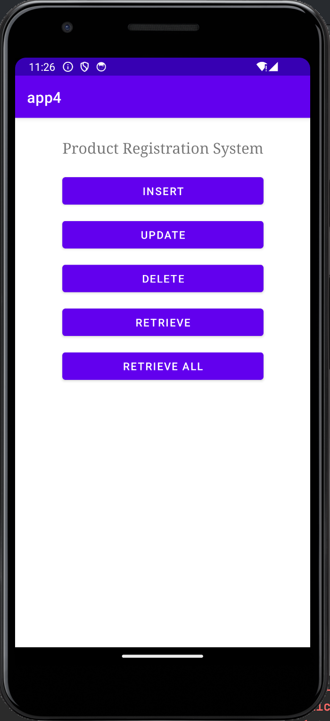

***Insert Retrieve***

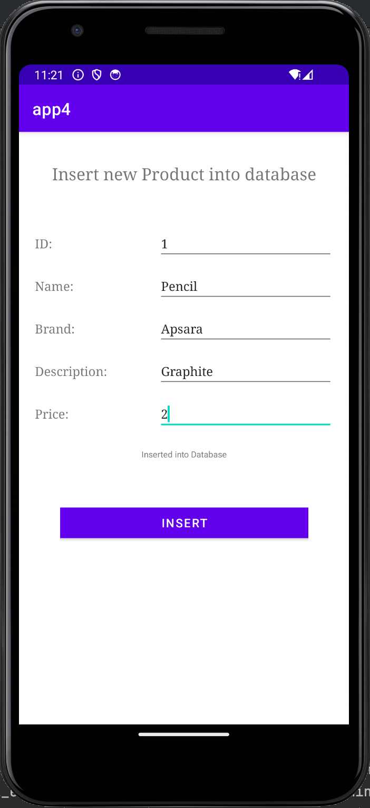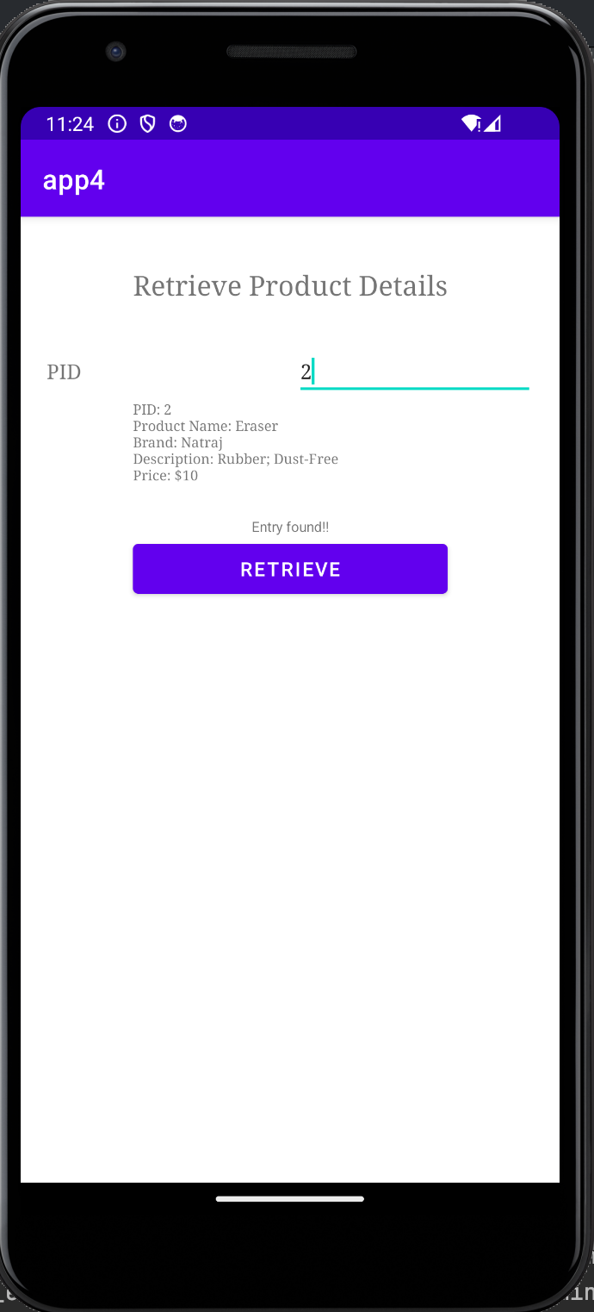

***Retrieve (Error)***

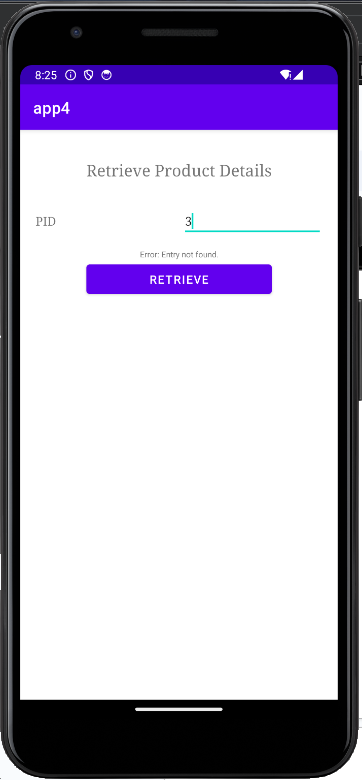

***Update Result***

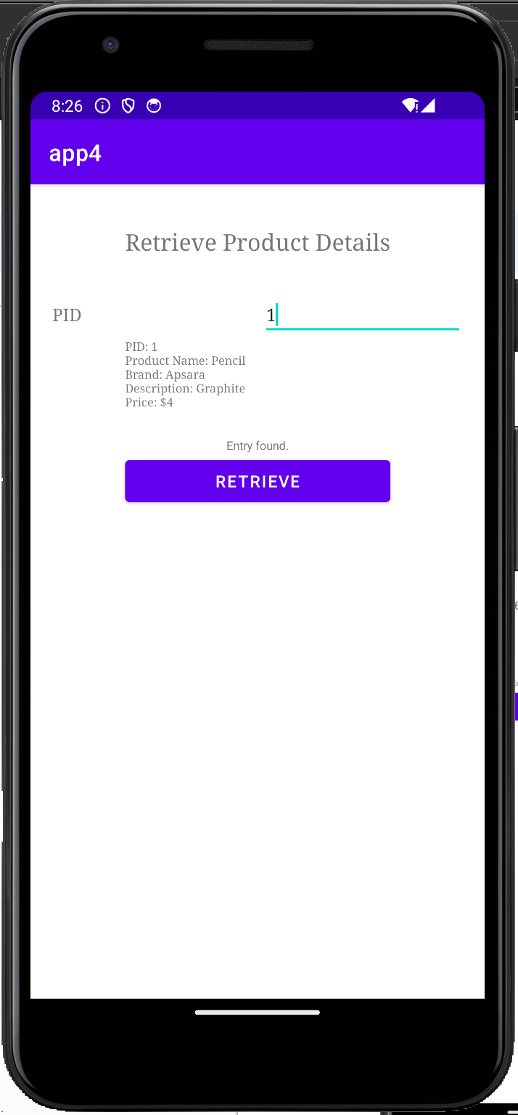 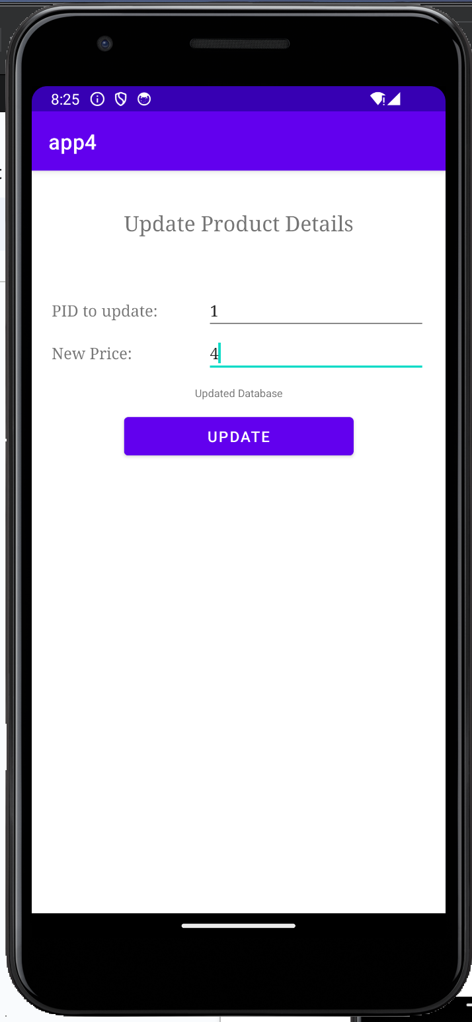

***Retrieve All***

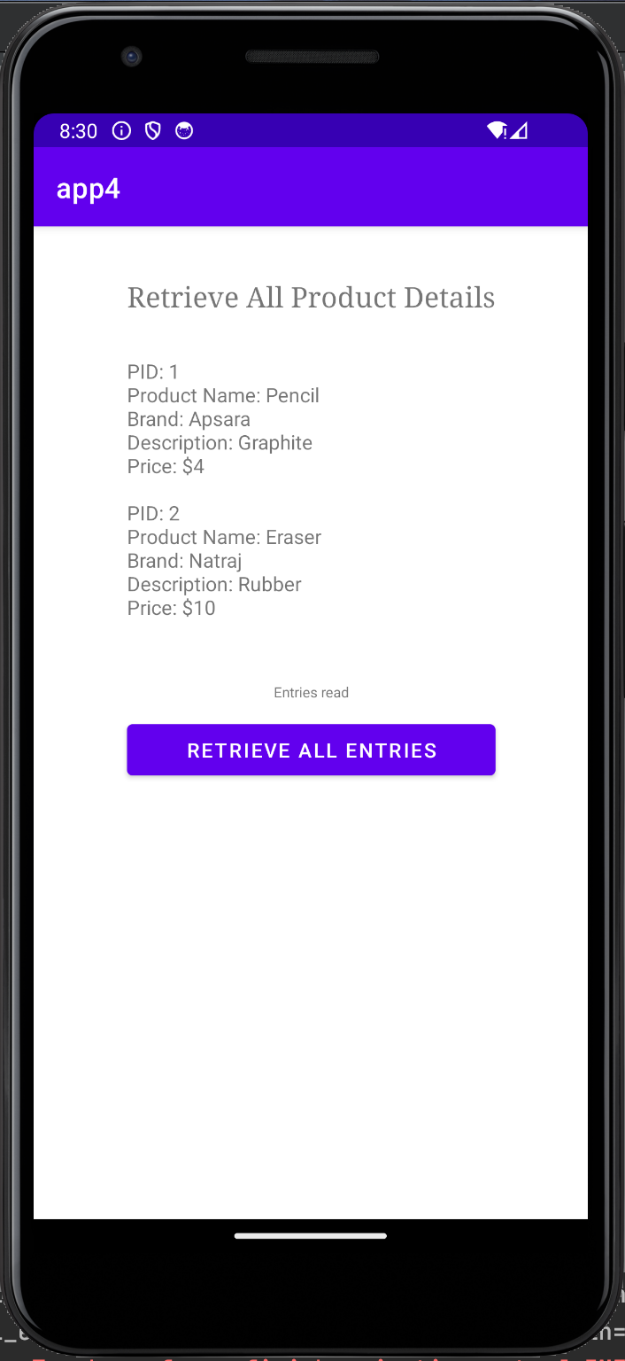

***Delete Result***

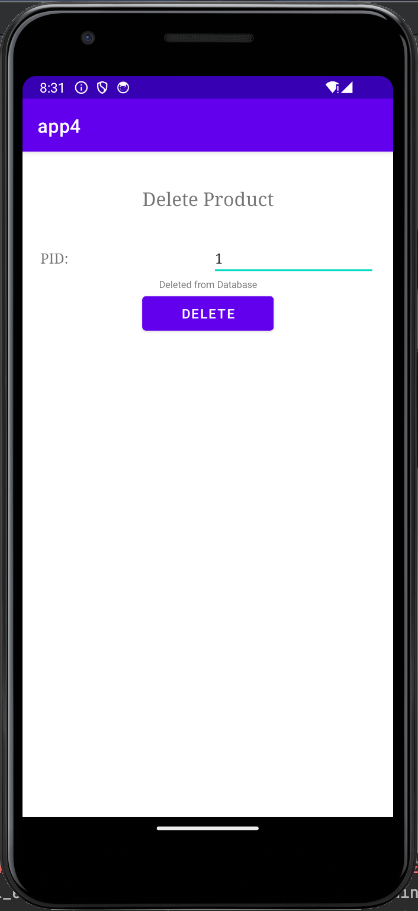 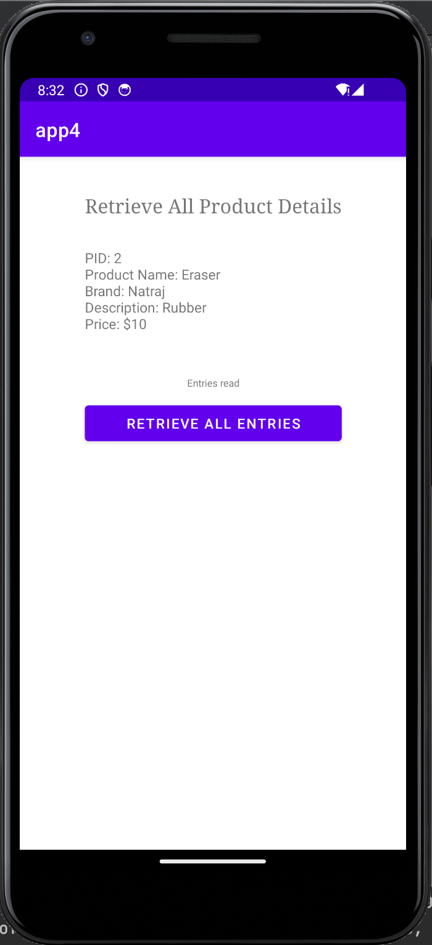

**Result**

The result of the exercise is an Android mobile application that allows users to manage product information. The application provides CRUD (Create, Read, Update, Delete) functionality for data stored in an SQLite database.

**Best Practices**

1. Developed a responsive, scrollable application that can be viewed on devices with varying screen sizes.

2. Used standard naming conventions to make the application easier to comprehend.

**Learning outcomes:**

* ● An android app was designed and implemented.
* ● SQLite database features were experimented with for a mobile application.

**ASSIGNMENT 5**

**Android Application using Multithreading**

**Oct 20, 2023**

**Question**

* Develop an android application to perform multithreading. Define 3 threads to run concurrently when the “start” button is clicked.
* a) The first thread should change the color of the text indefinitely
* b) The second thread should implement a moving banner
* c) The third thread should display a counter starting from 0 to 1000
* d) When the “Stop” button is pressed all the threads should be stopped
* e) When the “Resume” button is pressed all the threads should resume from the stopped point.

**Algorithm**

1. Initialize UI elements and thread control variables.

2. Set up onClickListeners for startButton, stopButton, and resumeButton.

onCreate():

3. Set content view to activity_main layout.

4. Initialize UI elements (colorChangingText, bannerText, counterText, startButton, stopButton, resumeButton).

5. Set onClickListeners for buttons.

startThreads():

6. Create colorChanger thread:

a. Define colors array.

b. Loop indefinitely while isRunning is true.

c. Check isColorThreadPaused flag.

d. Update colorChangingText with current color using runOnUiThread.

e. Sleep for a short duration.

7. Create bannerMover thread:

a. Loop indefinitely while isRunning is true.

b. Check isBannerThreadPaused flag.

c. Move bannerText back and forth using runOnUiThread and animate().

d. Sleep for a short duration.

8. Create counterThread:

a. Loop while isRunning is true and counter is less than 1000.

b. Check isCounterThreadPaused flag.

c. Update counterText with the current counter using runOnUiThread.

d. Increment counter.

e. Sleep for a short duration.

9. Start all three threads.

onStartButtonClick():

10. Set isRunning to true.

11. Set isColorThreadPaused, isBannerThreadPaused, and isCounterThreadPaused to false.

12. Call startThreads().

onStopButtonClick():

13. Set isRunning to false.

14. Set isColorThreadPaused, isBannerThreadPaused, and isCounterThreadPaused to true.

onResumeButtonClick():

15. Set isRunning to true.

16. Set isColorThreadPaused, isBannerThreadPaused, and isCounterThreadPaused to false.

17. Call startThreads().

**Source Code**

**//MainActivity.java**

package com.example.app5;

import androidx.annotation.RequiresApi;

import androidx.appcompat.app.AppCompatActivity;

import android.graphics.Color;

import android.os.Build;

import android.os.Bundle;

import android.text.Html;

import android.view.View;

import android.widget.Button;

import android.widget.TextView;

public class MainActivity extends AppCompatActivity {

private TextView colorChangingText, bannerText, counterText;

private Button startButton, stopButton, resumeButton;

private volatile boolean isColorThreadPaused = false;

private volatile boolean isBannerThreadPaused = false;

private volatile boolean isCounterThreadPaused = false;

private boolean isRunning = true;

private int counter = 0;

@Override

protected void onCreate(Bundle savedInstanceState) {

super.onCreate(savedInstanceState);

setContentView(R.layout.activity_main);

colorChangingText = findViewById(R.id.colorChangingText);

bannerText = findViewById(R.id.bannerText);

counterText = findViewById(R.id.counterText);

startButton = findViewById(R.id.startButton);

stopButton = findViewById(R.id.stopButton);

resumeButton = findViewById(R.id.resumeButton);

startButton.setOnClickListener(new View.OnClickListener() {

@Override

public void onClick(View v) {

isRunning = true;

isColorThreadPaused = false;

isBannerThreadPaused = false;

isCounterThreadPaused = false;

startThreads();

}

});

resumeButton.setOnClickListener(new View.OnClickListener() {

@Override

public void onClick(View v) {

isRunning = true;

isColorThreadPaused = false;

isBannerThreadPaused = false;

isCounterThreadPaused = false;

startThreads();

}

});

stopButton.setOnClickListener(new View.OnClickListener() {

@Override

public void onClick(View v) {

isRunning = false;

isColorThreadPaused = true;

isBannerThreadPaused = true;

isCounterThreadPaused = true;

}

});

}

private void startThreads(){

Thread colorChanger = new Thread(new Runnable() {

final String[] colorNames = {"#FFC3A0", "#FF677D", "#FFD966", "#B3E099", "#66B2FF", "#B98BDB"};

int colorIndex = 0;

@Override

public void run() {

while (isRunning) {

if (!isColorThreadPaused) {

final String currentColor = colorNames[colorIndex];

runOnUiThread(new Runnable() {

@RequiresApi(api = Build.VERSION_CODES.N)

@Override

public void run() {

String htmlColor = "<font color='" + currentColor + "'>Text Color</font>";

colorChangingText.setText(Html.fromHtml(htmlColor, Html.FROM_HTML_MODE_LEGACY));

}

});

// Cycle through the colors

colorIndex = (colorIndex + 1) % colorNames.length;

}

try {

Thread.sleep(1000);

} catch (InterruptedException e) {

Thread.currentThread().interrupt();

}

}

}

});

Thread bannerMover = new Thread(new Runnable() {

@Override

public void run() {

TextView bannerText = findViewById(R.id.bannerText);

final int bannerWidth = bannerText.getWidth();

final int animationDistance = bannerWidth - bannerText.getPaddingEnd();

int direction = 1;

while (isRunning){

if (!isBannerThreadPaused) {

int finalDirection = direction;

runOnUiThread(new Runnable() {

@Override

public void run() {

if (finalDirection == 1) {

// Move the bannerText to the right

bannerText.animate().translationX(animationDistance);

} else {

// Move the bannerText back to the left

bannerText.animate().translationX(0);

}

}

});

}

try {

Thread.sleep(1000);

}

catch (InterruptedException e ){

Thread.currentThread().interrupt();

}

direction *= -1;

}

}

});

Thread threadCounter = new Thread(new Runnable() {

@Override

public void run() {

while (isRunning && counter<1000){

if (!isCounterThreadPaused) {

final int currentCounter = counter;

runOnUiThread(new Runnable() {

@Override

public void run() {

counterText.setText("Counter: " + currentCounter);

}

});

counter++;

}

try {

Thread.sleep(1000); // Sleep for 1 second

} catch (InterruptedException e) {

Thread.currentThread().interrupt();

}

}

}

});

colorChanger.start();

bannerMover.start();

threadCounter.start();

}

}

**//activity_main.xml**

<?xml version="1.0" encoding="utf-8"?>

<androidx.constraintlayout.widget.ConstraintLayout xmlns:android="http://schemas.android.com/apk/res/android"

xmlns:app="http://schemas.android.com/apk/res-auto"

xmlns:tools="http://schemas.android.com/tools"

android:layout_width="match_parent"

android:layout_height="match_parent"

tools:context=".MainActivity">

<Button

android:id="@+id/startButton"

android:layout_width="wrap_content"

android:layout_height="wrap_content"

android:layout_marginTop="84dp"

android:text="Start"

app:layout_constraintEnd_toEndOf="parent"

app:layout_constraintHorizontal_bias="0.492"

app:layout_constraintStart_toStartOf="parent"

app:layout_constraintTop_toTopOf="parent" />

<TextView

android:id="@+id/colorChangingText"

android:layout_width="wrap_content"

android:layout_height="wrap_content"

android:layout_marginTop="100dp"

android:text="Text Color"

app:layout_constraintEnd_toEndOf="parent"

app:layout_constraintHorizontal_bias="0.498"

app:layout_constraintStart_toStartOf="parent"

app:layout_constraintTop_toBottomOf="@+id/startButton" />

<TextView

android:id="@+id/bannerText"

android:layout_width="wrap_content"

android:layout_height="wrap_content"

android:layout_marginTop="48dp"

android:text="I move!"

app:layout_constraintEnd_toEndOf="parent"

app:layout_constraintHorizontal_bias="0.498"

app:layout_constraintStart_toStartOf="parent"

app:layout_constraintTop_toBottomOf="@+id/colorChangingText" />

<TextView

android:id="@+id/counterText"

android:layout_width="wrap_content"

android:layout_height="wrap_content"

android:layout_marginTop="56dp"

android:text="Counter: 0"

app:layout_constraintEnd_toEndOf="parent"

app:layout_constraintHorizontal_bias="0.501"

app:layout_constraintStart_toStartOf="parent"

app:layout_constraintTop_toBottomOf="@+id/bannerText" />

<Button

android:id="@+id/stopButton"

android:layout_width="wrap_content"

android:layout_height="wrap_content"

android:layout_marginTop="96dp"

android:text="Stop"

app:layout_constraintEnd_toEndOf="parent"

app:layout_constraintHorizontal_bias="0.498"

app:layout_constraintStart_toStartOf="parent"

app:layout_constraintTop_toBottomOf="@+id/counterText" />

<Button

android:id="@+id/resumeButton"

android:layout_width="wrap_content"

android:layout_height="wrap_content"

android:layout_marginTop="52dp"

android:text="Resume"

app:layout_constraintEnd_toEndOf="parent"

app:layout_constraintHorizontal_bias="0.501"

app:layout_constraintStart_toStartOf="parent"

app:layout_constraintTop_toBottomOf="@+id/stopButton" />

</androidx.constraintlayout.widget.ConstraintLayout>

**Output Screenshot**

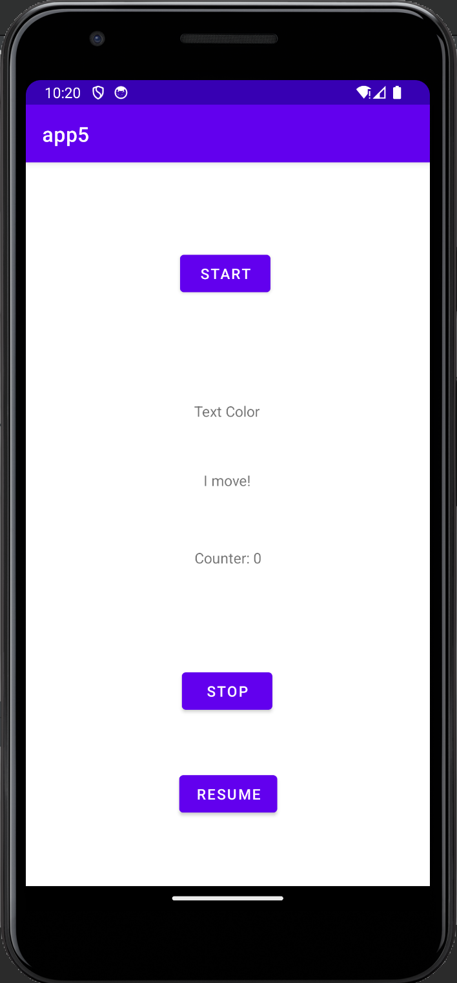 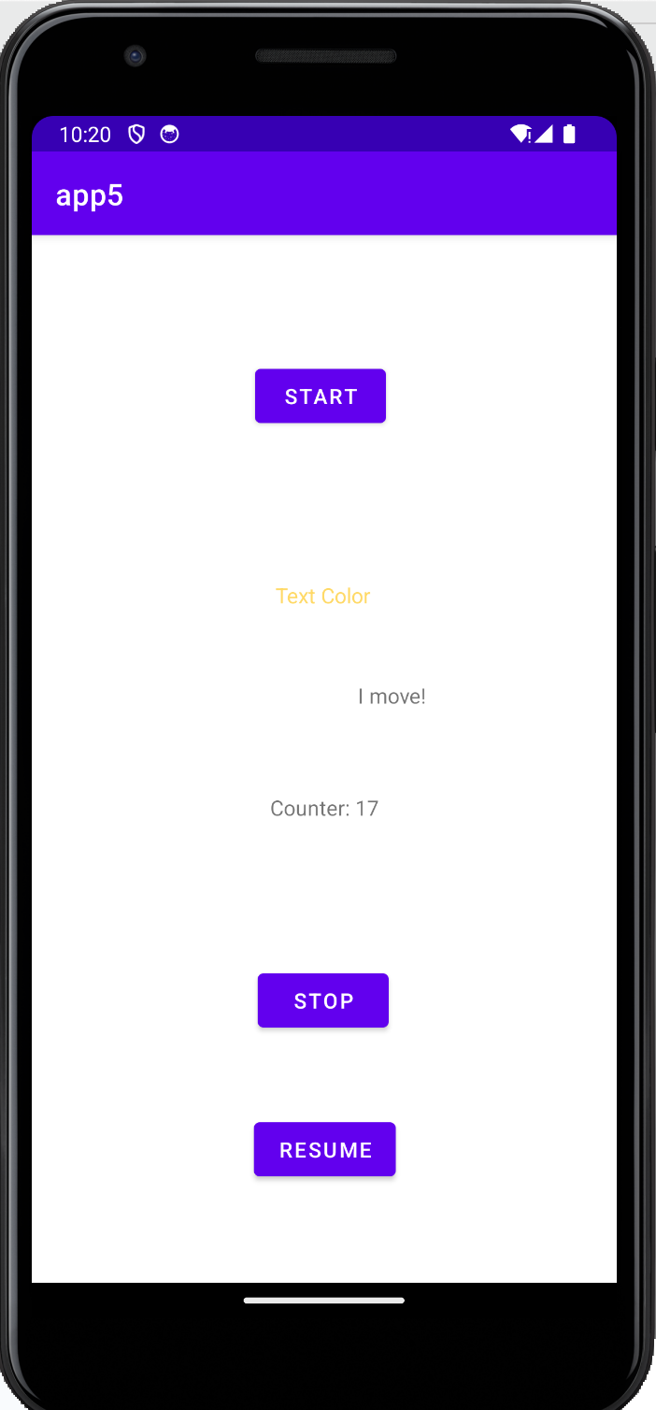 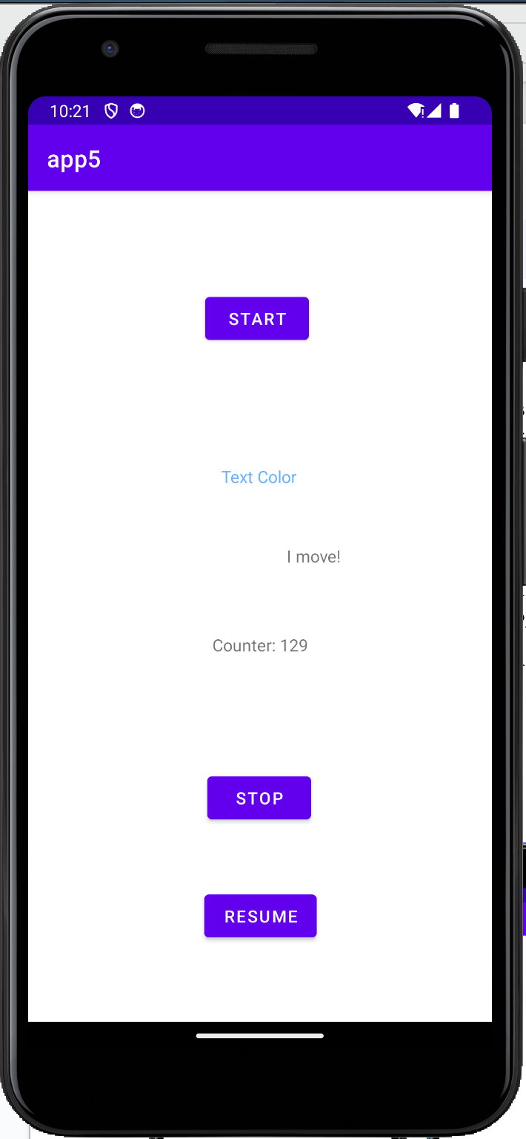

**Result**

The result of the exercise is an Android mobile application that allows users to perform multithreading.

**Best Practices**

1. Developed a responsive, scrollable application that can be viewed on devices with varying screen sizes.

2. Used standard naming conventions to make the application easier to comprehend.

**Learning outcomes:**

* ● An android app was designed and implemented.
* ● Multithreading features were experimented with for a mobile application.

**ASSIGNMENT 6**

**Finding geo coordinates of a location and Reverse Geocoding**

**Nov 02, 2023**

**Question**

* 6a) Develop an android application to find the latitude and longitude of current location and the selected location in a google map using anyone of the below options:
* 1) Location Manager
* 2) Network Provider
* 3) GPS Provider
* 6b) Also perform Reverse Geocoding i.e. given a latitude and longitude of a location, app should display the location name or given a location name it should display the latitude and longitude of that place.

**Algorithm**

1. Initialize UI elements and thread control variables.

**Source Code**

**//MainActivity.java**

package com.example.app6;

import android.content.pm.PackageManager;

import android.location.Address;

import android.location.Geocoder;

import android.location.Location;

import android.os.Bundle;

import android.view.View;

import android.widget.Button;

import android.widget.EditText;

import android.widget.TextView;

import android.widget.Toast;

import androidx.annotation.NonNull;

import androidx.appcompat.app.AppCompatActivity;

import androidx.core.app.ActivityCompat;

import androidx.core.content.ContextCompat;

import com.example.app6.R;

import com.google.android.gms.location.FusedLocationProviderClient;

import com.google.android.gms.location.LocationServices;

import com.google.android.gms.tasks.OnSuccessListener;

import java.io.IOException;

import java.util.List;

import java.util.Locale;

public class MainActivity extends AppCompatActivity {

private static final int LOCATION_PERMISSION_REQUEST = 1;

private FusedLocationProviderClient fusedLocationProviderClient;

private EditText locationNameEditText;

private Button searchLocationButton;

private TextView latitudeTextView, longitudeTextView, searchLatitudeTextView, searchLongitudeTextView;

@Override

protected void onCreate(Bundle savedInstanceState) {

super.onCreate(savedInstanceState);

setContentView(R.layout.activity_main);

fusedLocationProviderClient = LocationServices.getFusedLocationProviderClient(this);

locationNameEditText = findViewById(R.id.locationNameEditText);

searchLocationButton = findViewById(R.id.searchLocationButton);

latitudeTextView = findViewById(R.id.latitudeTextView);

longitudeTextView = findViewById(R.id.longitudeTextView);

searchLatitudeTextView = findViewById(R.id.searchLatitudeTextView);

searchLongitudeTextView = findViewById(R.id.searchLongitudeTextView);

findViewById(R.id.getLocationButton).setOnClickListener(new View.OnClickListener() {

@Override

public void onClick(View view) {

getLocation();

}

});

searchLocationButton.setOnClickListener(new View.OnClickListener() {

@Override

public void onClick(View view) {

searchLocation();

}

});

}

private void getLocation() {

if (ContextCompat.checkSelfPermission(this, android.Manifest.permission.ACCESS_FINE_LOCATION) == PackageManager.PERMISSION_GRANTED) {

fusedLocationProviderClient.getLastLocation().addOnSuccessListener(new OnSuccessListener<Location>() {

@Override

public void onSuccess(Location location) {

if (location != null) {

double latitude = location.getLatitude();

double longitude = location.getLongitude();

latitudeTextView.setText("Latitude: " + latitude);

longitudeTextView.setText("Longitude: " + longitude);

} else {

showToast("Location not available");

}

}

});

} else {

ActivityCompat.requestPermissions(this, new String[]{android.Manifest.permission.ACCESS_FINE_LOCATION}, LOCATION_PERMISSION_REQUEST);

}

}

private void searchLocation() {

String locationName = locationNameEditText.getText().toString().trim();

if (!locationName.isEmpty()) {

Geocoder geocoder = new Geocoder(this, Locale.getDefault());

try {

List<Address> addresses = geocoder.getFromLocationName(locationName, 1);

if (addresses != null && !addresses.isEmpty()) {

Address address = addresses.get(0);

double latitude = address.getLatitude();

double longitude = address.getLongitude();

searchLatitudeTextView.setText("Searched Latitude: " + latitude);

searchLongitudeTextView.setText("Searched Longitude: " + longitude);

} else {

showToast("Location not found");

}

} catch (IOException e) {

e.printStackTrace();

showToast("Geocoding error");

}

} else {

showToast("Please enter a location name");

}

}

@Override

public void onRequestPermissionsResult(int requestCode, @NonNull String[] permissions, @NonNull int[] grantResults) {

super.onRequestPermissionsResult(requestCode, permissions, grantResults);

if (requestCode == LOCATION_PERMISSION_REQUEST) {

if (grantResults.length > 0 && grantResults[0] == PackageManager.PERMISSION_GRANTED) {

getLocation();

} else {

showToast("Location permission denied");

}

}

}

private void showToast(String message) {

Toast.makeText(this, message, Toast.LENGTH_SHORT).show();

}

}

**//activity_main.xml**

<?xml version="1.0" encoding="utf-8"?>

<RelativeLayout xmlns:android="http://schemas.android.com/apk/res/android"

xmlns:app="http://schemas.android.com/apk/res-auto"

xmlns:tools="http://schemas.android.com/tools"

android:layout_width="match_parent"

android:layout_height="match_parent"

android:padding="16dp"

tools:context=".MainActivity">

<!-- Previous UI elements -->

<Button

android:id="@+id/getLocationButton"

android:layout_width="wrap_content"

android:layout_height="wrap_content"

android:layout_centerHorizontal="true"

android:text="Get Location" />

<TextView

android:id="@+id/latitudeTextView"

android:layout_width="wrap_content"

android:layout_height="wrap_content"

android:layout_below="@id/getLocationButton"

android:layout_centerHorizontal="true"

android:layout_marginTop="16dp"

android:text="Latitude: "

android:textSize="18sp" />

<TextView

android:id="@+id/longitudeTextView"

android:layout_width="wrap_content"

android:layout_height="wrap_content"

android:layout_below="@id/latitudeTextView"

android:layout_centerHorizontal="true"

android:layout_marginTop="8dp"

android:text="Longitude: "

android:textSize="18sp" />

<!-- New UI elements for search -->

<EditText

android:id="@+id/locationNameEditText"

android:layout_width="match_parent"

android:layout_height="wrap_content"

android:layout_below="@id/longitudeTextView"

android:layout_marginTop="16dp"

android:hint="Enter Location Name" />

<Button

android:id="@+id/searchLocationButton"

android:layout_width="wrap_content"

android:layout_height="wrap_content"

android:layout_below="@id/locationNameEditText"

android:layout_centerHorizontal="true"

android:layout_marginTop="16dp"

android:text="Search Location" />

<TextView

android:id="@+id/searchLatitudeTextView"

android:layout_width="wrap_content"

android:layout_height="wrap_content"

android:layout_below="@id/searchLocationButton"

android:layout_centerHorizontal="true"

android:layout_marginTop="16dp"

android:text="Searched Latitude: "

android:textSize="18sp" />

<TextView

android:id="@+id/searchLongitudeTextView"

android:layout_width="wrap_content"

android:layout_height="wrap_content"

android:layout_below="@id/searchLatitudeTextView"

android:layout_centerHorizontal="true"

android:layout_marginTop="8dp"

android:text="Searched Longitude: "

android:textSize="18sp" />

</RelativeLayout>

**Output Screenshot**

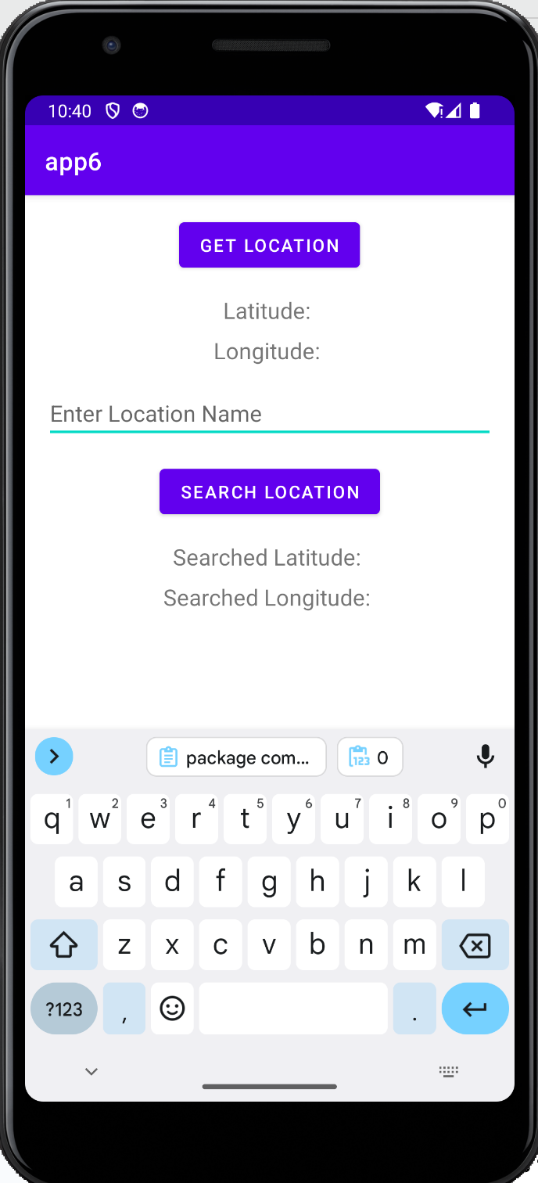 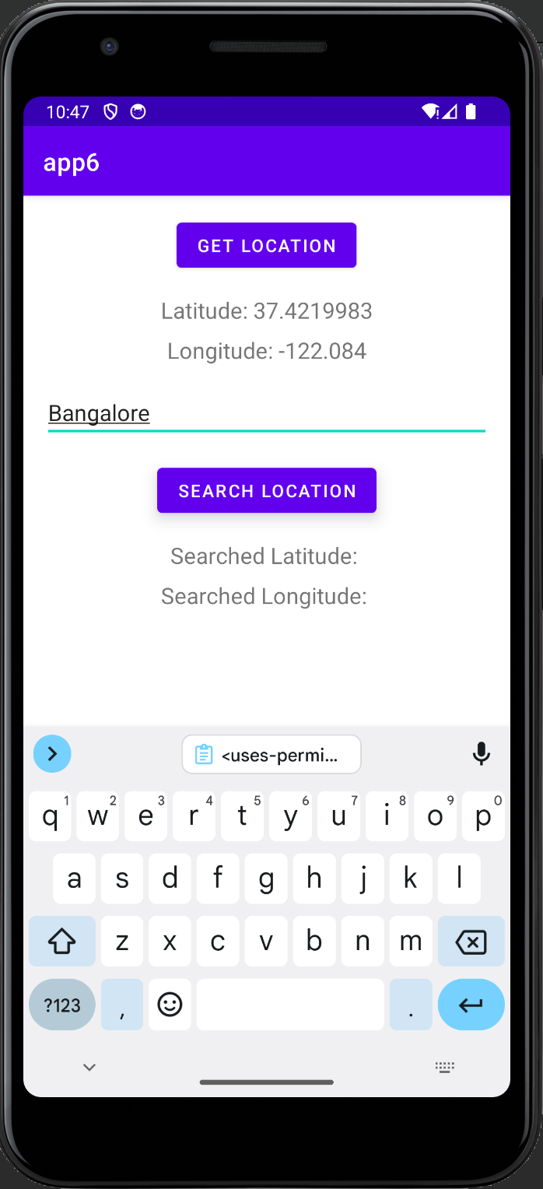

**Result**

The result of the exercise is an Android mobile application that applies Geocoding and Reverse Geocoding.

**Best Practices**

1. Developed a responsive, scrollable application that can be viewed on devices with varying screen sizes.

2. Used standard naming conventions to make the application easier to comprehend.

**Learning outcomes:**

* ● An android app was designed and implemented.
* ● Multithreading features were experimented with for a mobile application.